Vue3
github上的tags地址：https://github.com/vuejs/vue-next/releases/tag/v3.0.0
https://www.bilibili.com/video/BV1Zy4y1K7SH
📎vue3快速上手.md
📎vue3.jpg

一、Vue3 简介

1、Vue3 简介
- 2020年9月18日，Vue.js发布3.0版本，代号：One Piece（海贼王）
- 耗时2年多、2600+次提交、30+个RFC、600+次PR、99位贡献者
- github上的tags地址：https://github.com/vuejs/vue-next/releases/tag/v3.0.0

2、Vue3 带来了什么
- 性能的提升
  - 打包大小减少41%
  - 初次渲染快55%, 更新渲染快133%
  - 内存减少54%......
- 源码的升级
  - 使用Proxy代替defineProperty实现响应式
  - 重写虚拟DOM的实现和Tree-Shaking......
- 拥抱TypeScript
- 新的特性
- Composition API（组合API）
  - setup配置
  - ref与reactive
  - watch与watchEffect
  - provide与inject
  - ......
- 新的内置组件
  - Fragment
  - Teleport
  - Suspense
- 其他改变
  - 新的生命周期钩子
  - data 选项应始终被声明为一个函数
  - 移除keyCode支持作为 v-on 的修饰符
  - ......

二、创建 Vue3.0 工程

1、使用 vue-cli 创建

①、创建工程
官方文档：https://cli.vuejs.org/zh/guide/creating-a-project.html#vue-create
## 查看@vue/cli版本，确保@vue/cli版本在4.5.0以上
vue --version
## 安装或者升级你的@vue/cli
npm install -g @vue/cli
## 创建
vue create vue_test
## 启动
cd vue_test
npm run serve

②、分析工程结构
- main.js 简化
// 引入的不再是 Vue 构造函数了，而是一个名为 createApp 的工厂函数
import { createApp } from 'vue'
// 引入 app 组件，他是所有组件的父组件
import App from './App.vue'
// createApp(App).mount('#app')
// 创建应用实例对象：app(类似于之前 Vue2 中的 vm，但 app 比 vm 更“轻”)
const app = createApp(App)
// 挂载
app.mount('#app')
- 组件中可以没有根标签
<template>
<img alt="Vue logo" src="./assets/logo.png">
<HelloWorld msg="Welcome to Your Vue.js App"/>
</template>
<script>
import HelloWorld from './components/HelloWorld.vue'
export default {
name: 'App',
components: {
HelloWorld
}
}
</script>
- 工程结构
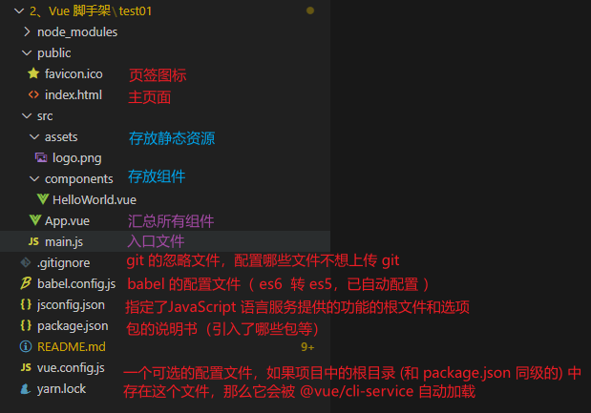

2、使用 vite 创建
- 官方文档：https://v3.cn.vuejs.org/guide/installation.html#vite
- vite官网：https://vitejs.cn
- 什么是vite？—— 新一代前端构建工具。
- 优势如下：
  - 开发环境中，无需打包操作，可快速的冷启动。
  - 轻量快速的热重载（HMR）。
  - 真正的按需编译，不再等待整个应用编译完成。
- 传统构建 与 vite构建对比图
[MISSING IMAGE: , ][MISSING IMAGE: , ]
## 创建工程
npm create vite@latest vue3-vite --template vue
## 输入 y 确定，并选择 Vue
Need to install the following packages:
create-vite@latest
Ok to proceed? (y) y
? Select a framework: » - Use arrow-keys. Return to submit.
Vanilla
> Vue
React
Preact
Lit
Svelte
Others
## 选择 JavaScript
√ Select a framework: » Vue
? Select a variant: » - Use arrow-keys. Return to submit.
> JavaScript
TypeScript
Customize with create-vue ↗
Nuxt ↗
## 进入工程目录
cd vue3-vite
## 安装依赖
npm install
## 运行
npm run dev
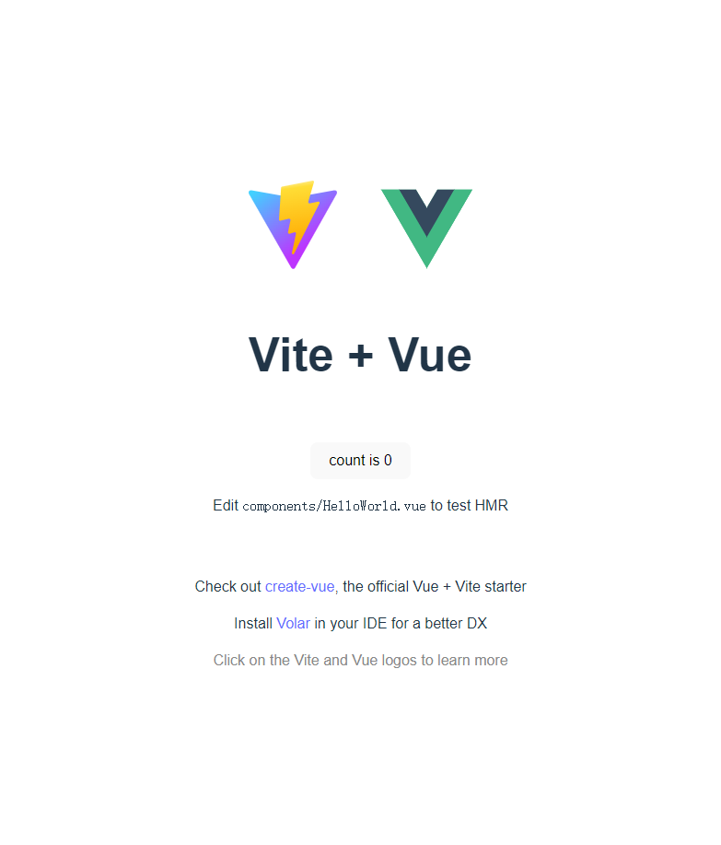

三、常用组合式 Composition API

1、拉开序幕的 setup
- 理解：Vue3.0 中一个新的配置项，值为一个函数。
- setup 是所有 Composition API（组合API）“ 表演的舞台 ”。
- 组件中所用到的：数据、方法等等，均要配置在 setup 中。
- setup 函数的两种返回值：
  - 若返回一个对象，则对象中的属性、方法，在模板中均可以直接使用。（重点关注！）
  - 若返回一个渲染函数：则可以自定义渲染内容。（了解）
- 注意点：
  - 尽量不要与 Vue2.x 配置混用
    - Vue2.x 配置（data、methos、computed...）中可以访问到 setup 中的属性、方法。
    - 但在 setup 中不能访问到 Vue2.x 配置（data、methos、computed...）。
    - 如果有重名，setup 优先。
  - setup 不能是一个 async 函数，因为返回值不再是 return 的对象，而是 promise，模板看不到 return 对象中的属性。（后期也可以返回一个Promise 实例，但需要 Suspense 和异步组件的配合）

// 引入的不再是 Vue 构造函数了，而是一个名为 createApp 的工厂函数
import { createApp } from 'vue'
// 引入 app 组件，他是所有组件的父组件
import App from './App.vue'
// createApp(App).mount('#app')
// 创建应用实例对象：app(类似于之前 Vue2 中的 vm，但 app 比 vm 更“轻”)
const app = createApp(App)
// 挂载
app.mount('#app')
<template>
<HelloWorld />
</template>
<script>
import HelloWorld from './components/HelloWorld.vue'
export default {
name: 'App',
components: { HelloWorld }
}
</script>
<template>
<h1>姓名：{{name}}</h1>
<button @click="hello">介绍</button>
</template>
<script>
// 引入渲染函数 h
// import { h } from 'vue'
export default {
name: 'HelloWorld',
setup(){
// 数据
let name = "月海";
let age = 16;
// 方法
function hello(){
alert(`姓名：${name}，年龄：${age}`)
}
// 返回一个对象，则对象中的属性、方法，在模板中均可以直接使用
return { name, hello }
// 返回一个渲染函数：则可以自定义渲染内容；需要引入渲染函数 h
// return ()=> h( 'name', '1111111111111111111')
}
}
</script>

2、ref 函数
- 作用：定义一个响应式的数据
- 语法：const xxx = ref(initValue)
  - 创建一个包含响应式数据的引用对象（reference对象，简称ref对象）。
  - JS中操作数据： xxx.value
  - 模板中读取数据：不需要.value，直接：<div>{{xxx}}</div>
- 备注：
  - 接收的数据可以是：基本类型、也可以是对象类型。
  - 基本类型的数据：响应式依然是靠 Object.defineProperty() 的 get 与 set 完成的。
  - 对象类型的数据：内部 “ 求助 ” 了 Vue3.0 中的一个新函数：reactive 函数。
<template>
<h1>姓名：{{name}}</h1>
<h4>工作：{{job.type}}</h4>
<h4>工资：{{job.salary}}</h4>
<button @click="hello">介绍</button>
<button @click="update">修改</button>
</template>
<script>
// 引入 vue 函数
import { ref } from 'vue'
export default {
name: 'HelloWorld',
setup(){
// 数据
let name = ref("月海");
let age = ref(16);
let job = ref({
type: "java",
salary: 6000
})
// 方法
function hello(){
alert(`姓名：${name.value}，年龄：${age.value}`)
}
function update(){
name.value = "言";
age.value = 14;
job.value.type = 'vue';
job.value.salary = 5000;
}
// 返回一个对象，则对象中的属性、方法，在模板中均可以直接使用
return { name, job, hello, update }
}
}
</script>

3、reactive 函数
- 作用：定义一个对象类型的响应式数据（基本类型不要用它，要用 ref 函数）
- 语法：const 代理对象 = reactive(源对象) 接收一个对象（或数组），返回一个代理对象（Proxy 的实例对象，简称 proxy 对象）
- reactive 定义的响应式数据是“深层次的”。
- 内部基于 ES6 的 Proxy 实现，通过代理对象操作源对象内部数据进行操作。
<template>
<h1>姓名：{{person.name}}</h1>
<h4>工作：{{person.job.type}}</h4>
<h4>工资：{{person.job.salary}}</h4>
<ul>
<li v-for="(hobby, index) in person.hobbys" :key="hobby">
{{hobby}}
<button @click="update2(index)">* 10</button>
</li>
</ul>
<button @click="hello">介绍</button>
<button @click="update">修改</button>
</template>
<script>
// 引入 vue 函数
import { reactive } from 'vue'
export default {
name: 'HelloWorld',
setup(){
const data = reactive({
person: {
name: "月海",
age: 16,
job: {
type: "java",
salary: 6000
},
hobbys: [ 1,2,3,4,5 ]
}
})
// 方法
function hello(){
alert(`姓名：${data.person.name}，年龄：${data.person.age}`)
}
function update(){
data.person.name = "言";
data.person.age = 14;
// 使用 reactive 不用再 .value
data.person.job.type = 'vue';
data.person.job.salary = 5000;
data.person.hobbys[0] = 22;
}
function update2(index){
data.person.hobbys[index] = data.person.hobbys[index] * 10;
}
// 返回一个对象，则对象中的属性、方法，在模板中均可以直接使用
return { ...data, hello, update, update2 }
}
}
</script>

4、Vue3.0 中的响应式原理

①、vue2.x 的响应式
- 实现原理：
  - 对象类型：通过 Object.defineProperty() 对属性的读取、修改进行拦截（数据劫持）。
  - 数组类型：通过重写更新数组的一系列方法来实现拦截。（对数组的变更方法进行了包裹）。
Object.defineProperty(data, 'count', {
get () {},
set () {}
})
- 存在问题：
  - 新增属性、删除属性，界面不会更新。
  - 直接通过下标修改数组，界面不会自动更新

②、Vue3.0 的响应式
https://www.bilibili.com/video/BV1Zy4y1K7SH/?p=146
- 实现原理：
- 通过 Proxy（代理）：拦截对象中任意属性的变化, 包括：属性值的读写、属性的添加、属性的删除等。
- 通过 Reflect（反射）：对源对象的属性进行操作。
- MDN 文档中描述的 Proxy 与 Reflect：
  - Proxy：https://developer.mozilla.org/zh-CN/docs/Web/JavaScript/Reference/Global_Objects/Proxy
  - Reflect：https://developer.mozilla.org/zh-CN/docs/Web/JavaScript/Reference/Global_Objects/Reflect
new Proxy(data, {
/**
* 拦截读取属性值
* target：原数据，就是 data
* prop：读取的数据
*/
get (target, prop) {
return Reflect.get(target, prop)
},
/**
* 拦截设置属性值或添加新属性
* target：原数据，就是 data
* prop：读取的数据
* value：修改或添加的新值
*/
set (target, prop, value) {
return Reflect.set(target, prop, value)
},
// 拦截删除属性
deleteProperty (target, prop) {
return Reflect.deleteProperty(target, prop)
}
})
proxy.name = 'tom'

5、reactive 对比 ref
- 从定义数据角度对比：
  - ref 用来定义：基本类型数据。
  - reactive 用来定义：对象（或数组）类型数据。
  - 备注：ref 也可以用来定义对象（或数组）类型数据，它内部会自动通过 reactive 转为代理对象。
- 从原理角度对比：
  - ref 通过 Object.defineProperty() 的 get 与 set 来实现响应式（数据劫持）。
  - reactive 通过使用 Proxy 来实现响应式（数据劫持），并通过 Reflect 操作源对象内部的数据。
- 从使用角度对比：
  - ref 定义的数据：操作数据需要 .value，读取数据时模板中直接读取不需要 .value。
  - reactive 定义的数据：操作数据与读取数据：均不需要 .value。

6、setup 的两个注意点
- setup 执行的时机
  - 在 beforeCreate 之前执行一次，this 是 undefined。
- setup 的参数
  - props：值为对象，包含：组件外部传递过来，且组件内部声明接收了的属性。
  - context：上下文对象
    - attrs：值为对象，包含：组件外部传递过来，但没有在 props 配置中声明的属性，相当于 this.$attrs。
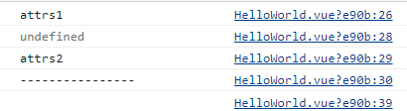
    - emit：分发自定义事件的函数，相当于 this.$emit。
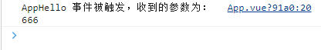
    - slots：收到的插槽内容，相当于 this.$slots。
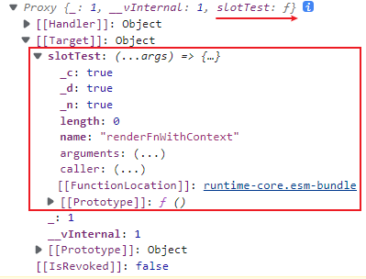

// 引入的不再是 Vue 构造函数了，而是一个名为 createApp 的工厂函数
import { createApp } from 'vue'
// 引入 app 组件，他是所有组件的父组件
import App from './App.vue'
// 创建应用实例对象并挂载：app(类似于之前 Vue2 中的 vm，但 app 比 vm 更“轻”)
createApp(App).mount('#app')
<template>
<!-- @HelloWorldHello="AppHello"：给子组件绑定 HelloWorldHello 事件，被触发时调用父组件的 AppHello 函数 -->
<HelloWorld @HelloWorldHello="AppHello" attrsTest1="attrs1" attrsTest2="attrs2">
<!-- 插槽 -->
<template v-slot:slotTest>
<p>yuehai</p>
</template>
</HelloWorld>
</template>
<script>
import HelloWorld from './components/HelloWorld.vue'
export default {
name: 'App',
components: { HelloWorld },
setup(){
function AppHello(value){
console.log(`AppHello 事件被触发，收到的参数为：${value}`)
}
return { AppHello }
}
}
</script>
<template>
<h1>{{person.name}}</h1>
<button @click="test">触发 HelloWorldHello 事件</button>
<slot name="slotTest"></slot>
</template>
<script>
// 引入 vue 函数
import { reactive } from 'vue'
export default {
name: 'HelloWorld',
// props：声明接收父组件传过来的参数
props: [ 'attrsTest1' ],
// emits：声明接收父组件绑定的事件，不过触发还是需要通过 context.emit，所以这个属性配不配置没有影响
emits: [ 'HelloWorldHello' ],
// setup 执行的时机，在 beforeCreate 之前执行一次，this 是 undefined
setup(props, context){
const data = reactive({
person: {
name: "月海"
}
})
// props：值为对象，包含：组件外部传递过来，且组件内部声明接收了的属性
console.log(props.attrsTest1)
// 1、attrs：值为对象，包含：组件外部传递过来，但没有在 props 配置中声明的属性，相当于 this.$attrs
console.log(context.attrs.attrsTest1)
console.log(context.attrs.attrsTest2)
console.log("----------------")
// 2、emit：分发自定义事件的函数，相当于 this.$emit
function test(){
// 触发绑定给此组件的 HelloWorldHello 事件，传递参数 666
context.emit("HelloWorldHello", 666)
}
// 3、slots：收到的插槽内容，相当于 this.$slots
console.log(context.slots)
// 返回一个对象，则对象中的属性、方法，在模板中均可以直接使用
return { ...data, test }
}
}
</script>

7、计算属性与监视属性

①、计算属性 computed 函数
- 与 Vue2.x 中 computed 配置功能一致
- 写法
<template>
姓：<input type="text" v-model="person.firstName"><br>
名：<input type="text" v-model="person.lastName"><br>
<h1>全名：{{person.fullName}}</h1>
<h1>全名：<input type="text" v-model="person.fullName2"></h1>
</template>
<script>
// 引入 vue 函数
import { reactive, computed } from 'vue'
export default {
name: 'HelloWorld',
setup(){
const data = reactive({
person: {
firstName: '月海',
lastName: 'yuehai'
}
})
// 使用计算属性：简写形式，没有考虑计算属性被修改的情况
data.person.fullName = computed(()=>{
return `${data.person.firstName}-${data.person.lastName}`
})
// 使用计算属性：完整形式，考虑读写
data.person.fullName2 = computed({
get(){
return `${data.person.firstName}-${data.person.lastName}`
},
set(value){
const arr = value.split('-');
data.person.firstName = arr[0];
data.person.lastName = arr[1];
}
})
// 返回一个对象，则对象中的属性、方法，在模板中均可以直接使用
return { ...data }
}
}
</script>

②、监视属性watch 函数
- 与 Vue2.x 中 watch 配置功能一致
- 监视使用 ref 定义的基本属性时不用 .value
- 两个小“坑”：
  - 监视 reactive 定义的响应式数据时：oldValue 无法正确获取、强制开启了深度监视（deep 配置失效）。
  - 监视 reactive 定义的响应式数据中某个属性时：deep 配置有效。
<template>
<h2>当前求和为：{{sum}}</h2>
<button @click="sum++">点击+1</button><hr>
<h2>当前求和 2 为：{{sum2}}</h2>
<h2>当前信息为：{{msg}}</h2>
<button @click="sum2++">点击+1</button>
<button @click="msg = msg + '！'">点击显示信息</button><hr>
<h2>姓名：{{person.name}}</h2>
<h2>年龄：{{person.age}}</h2>
<h2>java：{{person.job.java}}</h2>
<button @click="person.name = person.name + '~'">修改姓名</button>
<button @click="person.age ++">修改年龄</button>
<button @click="person.job.java = person.job.java + 500">修改薪资</button><hr>
</template>
<script>
// 引入 vue 函数
import { ref, reactive, watch} from 'vue'
export default {
name: 'HelloWorld',
setup(){
// 基本类型要使用 ref，若是使用 reactive，必须为对象或数组
let sum = ref(0);
let sum2 = ref(0);
let msg = ref('你好啊');
const person = reactive({
name: '月海',
age: 18,
job: {
java: 1000
}
})
// 情况一：监视 ref 所定义的一个响应式数据
// 参数 1：监视的属性是谁
// 参数 2：监视的回调
// 参数 3：配置项：
// 配置项：立即执行 immediate
// 配置项：深度监视 deep
watch(sum, (newValue, oldValue)=>{
console.log('sum 发生了改变', newValue, oldValue)
}, {immediate: true, deep: true})
// 情况二：监视 ref 所定义的多个响应式数据，将所要监视的属性放入数组传递，此时 newValue 和 oldValue 的值也是数组
watch([sum2, msg], (newValue, oldValue)=>{
console.log('sum 或 msg 发生了改变', newValue, oldValue)
})
// 情况三：监视 reactive 定义的响应式数据，无法正确获得 oldValue，且强制开启了深度监视（deep：true）不可关闭
// watch(person, (newValue, oldValue)=>{
// console.log('person 发生了改变', newValue, oldValue)
// })
// 情况四：监视 reactive 定义的响应式数据中的某个属性，需传入一个函数，监视其返回值，此方法的 oldValue 可以正确获得
watch(()=>person.age, (newValue, oldValue)=>{
console.log('person 发生了改变', newValue, oldValue)
})
// 情况五：监视 reactive 定义的响应式数据中的某些属性，将所要监视的属性放入数组传递，此时 newValue 和 oldValue 的值也是数组
watch([()=>person.name, ()=>person.age], (newValue, oldValue)=>{
console.log('person 发生了改变', newValue, oldValue)
})
// 特殊情况：监视 reactive 定义的响应式数据中对象，若其中还有嵌套的对象，则要开启深度监视，但依然无法正确获得 oldValue
watch(()=>person.job, (newValue, oldValue)=>{
console.log('person.job 发生了改变', newValue, oldValue)
}, {deep: true})
// 返回一个对象，则对象中的属性、方法，在模板中均可以直接使用
return { sum, sum2, msg, person }
}
}
</script>

③、监视属性watchEffect 函数
- watch 的套路是：既要指明监视的属性，也要指明监视的回调。
- watchEffect 的套路是：不用指明监视哪个属性，监视的回调中用到哪个属性，那就监视哪个属性。
- watchEffect 有点像 computed：
  - 但 computed 注重的计算出来的值（回调函数的返回值），所以必须要写返回值。
  - 而 watchEffect 更注重的是过程（回调函数的函数体），所以不用写返回值。
<template>
<h2>当前求和为：{{sum}}</h2>
<button @click="sum++">点击+1</button><hr>
<h2>姓名：{{person.name}}</h2>
<h2>年龄：{{person.age}}</h2>
<h2>java：{{person.job.java}}</h2>
<button @click="person.name = person.name + '~'">修改姓名</button>
<button @click="person.age ++">修改年龄</button>
<button @click="person.job.java = person.job.java + 500">修改薪资</button><hr>
</template>
<script>
import {reactive, ref, watchEffect} from 'vue'
export default {
name: "watchEffectTest",
setup(){
// 基本类型要使用 ref，若是使用 reactive，必须为对象或数组
let sum = ref(0);
const person = reactive({
name: '月海',
age: 18,
job: {
java: 1000
}
})
watchEffect(()=>{
let java = person.job.java
console.log(`当前求和为${sum.value}，当前薪资为${java}`)
})
// 返回一个对象，则对象中的属性、方法，在模板中均可以直接使用
return { sum, person }
}
}
</script>
<style scoped>
</style>

8、生命周期

①、vue2.x 的生命周期
[MISSING IMAGE: , ]

②、vue3.0 的生命周期
- vue3.0 中可以继续使用 Vue2.x 中的生命周期钩子，但有有两个被更名：
  - beforeDestroy 改名为 beforeUnmount
  - destroyed 改名为 unmounted
<template>
<button @click="isShow = !isShow">切换隐藏/显示</button>
<HelloWorld v-if="isShow" />
</template>
<script>
// 引入 vue 函数
import { ref } from 'vue'
// 引入组件
import HelloWorld from './components/HelloWorld.vue'
export default {
name: 'App',
components: { HelloWorld },
setup(){
let isShow = ref(true)
// 返回一个对象，则对象中的属性、方法，在模板中均可以直接使用
return { isShow }
}
}
</script>
<template>
<h2>当前求和为：{{sum}}</h2>
<button @click="sum++">点击+1</button><hr>
</template>
<script>
// 引入 vue 函数
import { ref } from 'vue'
export default {
name: 'HelloWorld',
setup(){
// 基本类型要使用 ref，若是使用 reactive，必须为对象或数组
let sum = ref(0);
// 返回一个对象，则对象中的属性、方法，在模板中均可以直接使用
return { sum }
},
// 通过配置项 的形式使用生命周期钩子
beforeCreate() {
console.log('----初始化之前：beforeCreate----')
},
created() {
console.log('----初始化完成：created----')
},
beforeMount() {
console.log('----挂载之前：beforeMount----')
},
mounted() {
console.log('----挂载完成：mounted----')
},
beforeUpdate() {
console.log('----更新之前：beforeUpdate----')
},
updated() {
console.log('----更新完成：updated----')
},
beforeUnmount() {
console.log('----卸载之前：beforeUnmount----')
},
unmounted() {
console.log('----卸载完成：unmounted----')
}
}
</script>
- Vue3.0 也提供了 Composition API 形式的生命周期钩子，与 Vue2.x 中钩子对应关系如下：
  - 初始化之前：beforeCreate===>setup()
  - 初始化完成：created=======>setup()
  - 挂载之前：beforeMount====>onBeforeMount
  - 挂载完成：mounted=======>onMounted
  - 更新之前：beforeUpdate===>onBeforeUpdate
  - 更新完成：updated=======>onUpdated
  - 卸载之前：beforeUnmount==>onBeforeUnmount
  - 卸载完成：unmounted=====>onUnmounted
<template>
<h2>当前求和为：{{sum}}</h2>
<button @click="sum++">点击+1</button><hr>
</template>
<script>
// 引入 vue 函数
import { ref, onBeforeMount, onMounted, onBeforeUpdate, onUpdated, onBeforeUnmount, onUnmounted } from 'vue'
export default {
name: 'HelloWorld2',
setup(){
// 基本类型要使用 ref，若是使用 reactive，必须为对象或数组
let sum = ref(0);
console.log('----初始化之前：beforeCreate----')
console.log('----初始化完成：created----')
// 通过组合式 api 的形式使用生命周期钩子
onBeforeMount(()=>{
console.log('----挂载之前：beforeMount----')
})
onMounted(()=>{
console.log('----挂载完成：mounted----')
})
onBeforeUpdate(()=>{
console.log('----更新之前：beforeUpdate----')
})
onUpdated(()=>{
console.log('----更新完成：updated----')
})
onBeforeUnmount(()=>{
console.log('----卸载之前：beforeUnmount----')
})
onUnmounted(()=>{
console.log('----卸载完成：unmounted----')
})
// 返回一个对象，则对象中的属性、方法，在模板中均可以直接使用
return { sum }
},
}
</script>
[MISSING IMAGE: , ]

9、自定义 hook 函数
- 什么是 hook：本质是一个函数，把 setup 函数中使用的 Composition API 进行了封装。
- 类似于 vue2.x 中的 mixin。
- 自定义 hook 的优势：复用代码，让 setup 中的逻辑更清楚易懂。
// 引入的不再是 Vue 构造函数了，而是一个名为 createApp 的工厂函数
import { createApp } from 'vue'
// 引入 app 组件，他是所有组件的父组件
import App from './App.vue'
// 创建应用实例对象并挂载：app(类似于之前 Vue2 中的 vm，但 app 比 vm 更“轻”)
createApp(App).mount('#app')
- 在 src 目录下创建 hooks 目录，在其中创建 usePoint.js 文件
import {onBeforeUnmount, onMounted, reactive} from 'vue'
// 显示鼠标点击的坐标，将逻辑写在一个函数里
function savePoint(){
// 基本类型要使用 ref，若是使用 reactive，必须为对象或数组
const point = reactive({
x: 0,
y: 0
})
// 给坐标赋值
function savePoint(event){
point.x = event.pageX;
point.y = event.pageY;
console.log(event.pageX, event.pageY)
}
// 挂载完成，绑定点击事件
onMounted(()=> {
window.addEventListener('click', savePoint)
})
// 卸载之前，删除绑定事件
onBeforeUnmount(()=>{
window.removeEventListener('click', savePoint)
})
// 最后需要返回数据
return point;
}
// 暴露
export default { savePoint }
<template>
<h2>当前鼠标点击的坐标为：<br>X：{{point.x}}，Y：{{point.y}}</h2>
</template>
<script>
// 引入 vue 函数
import { } from 'vue'
// 引入 hook 函数
import UsePoint from '@/hooks/usePoint'
export default {
name: 'HelloWorld',
setup(){
// 调用 UsePoint 中的 savePoint() 函数，得到其返回值
let point = UsePoint.savePoint()
// 返回一个对象，则对象中的属性、方法，在模板中均可以直接使用
return { point }
}
}
</script>
<template>
<button @click="isShow = !isShow">切换隐藏/显示</button>
<HelloWorld v-if="isShow" />
</template>
<script>
// 引入组件
import HelloWorld from './components/HelloWorld.vue'
import {ref} from 'vue'
export default {
name: 'App',
components: { HelloWorld },
setup(){
let isShow = ref(true)
// 返回一个对象，则对象中的属性、方法，在模板中均可以直接使用
return { isShow }
}
}
</script>

10、toRef
- 作用：创建一个 ref 对象，其 value 值指向另一个对象中的某个属性。
- 语法：const name = toRef(person,'name')
- 应用：要将响应式对象中的某个属性单独提供给外部使用时。
<template>
<h2>姓名：{{name}}</h2>
<h2>年龄：{{person.age}}</h2>
<h2>java：{{javaToRef}}</h2>
<button @click="name = name + '~'">修改姓名</button>
<button @click="person.age ++">修改年龄</button>
<button @click="javaToRef = javaToRef + 500">修改薪资</button><hr>
</template>
<script>
// 引入 vue 函数
import { reactive, toRef } from 'vue'
export default {
name: 'HelloWorld',
setup(){
// 基本类型要使用 ref，若是使用 reactive，必须为对象或数组
const person = reactive({
name: '月海',
age: 18,
job: {
java: 1000
}
})
// 返回一个对象，则对象中的属性、方法，在模板中均可以直接使用
return {
// 返回 person，模板中可通过 person.xxx 使用
person,
// 使用 toRef 返回 person 中的 name 属性，模板中可通过 name 使用
name: toRef(person, 'name'),
// 使用 toRef 返回 person.job 中的 java 属性，模板中可通过 javaToRef 使用
javaToRef: toRef(person.job, 'java'),
}
}
}
</script>
- 扩展：toRefs 与 toRef 功能一致，但可以批量创建多个 ref 对象，语法：toRefs(person)
<template>
<h2>姓名：{{name}}</h2>
<h2>年龄：{{age}}</h2>
<h2>java：{{job.java}}</h2>
<button @click="name = name + '~'">修改姓名</button>
<button @click="age ++">修改年龄</button>
<button @click="job.java = job.java + 500">修改薪资</button><hr>
</template>
<script>
// 引入 vue 函数
import { reactive, toRefs } from 'vue'
export default {
name: 'ToRefsTest',
setup(){
// 基本类型要使用 ref，若是使用 reactive，必须为对象或数组
const person = reactive({
name: '月海',
age: 18,
job: {
java: 1000
}
})
// 返回一个对象，则对象中的属性、方法，在模板中均可以直接使用
return {
// 使用 toRefs
...toRefs(person)
}
}
}
</script>

四、其它组合式 Composition API

1、shallowReactive 与 shallowRef
- shallowReactive：只处理对象最外层属性的响应式（浅响应式）。
- shallowRef：只处理基本数据类型的响应式，不进行对象的响应式处理。
- 什么时候使用?
  - 如果有一个对象数据，结构比较深，但变化时只是外层属性变化：shallowReactive。
  - 如果有一个对象数据，后续功能不会修改该对象中的属性，而是生新的对象来替换：shallowRef。

2、readonly 与 shallowReadonly
- readonly：让一个响应式数据变为只读的（深只读），所有数据都不可更改
- shallowReadonly：让一个响应式数据变为只读的（浅只读），只有第一层不可修改，嵌套的对象可以修改
- 应用场景：不希望数据被修改时。
<template>
<h2>姓名：{{name}}</h2>
<h2>年龄：{{age}}</h2>
<h2>java：{{job.java}}</h2>
<button @click="name = name + '~'">修改姓名</button>
<button @click="age ++">修改年龄</button>
<button @click="job.java = job.java + 500">修改薪资</button><hr>
</template>
<script>
// 引入 vue 函数
import { reactive, toRefs, readonly, shallowReadonly } from 'vue'
export default {
name: 'HelloWorld',
setup(){
// 基本类型要使用 ref，若是使用 reactive，必须为对象或数组
let person = reactive({
name: '月海',
age: 18,
job: {
java: 1000
}
})
// 1. readonly：让一个响应式数据变为只读的（深只读），所有数据都不可更改
// person = readonly(person);
// 2. shallowReadonly：让一个响应式数据变为只读的（浅只读），只有第一层不可修改，嵌套的对象可以修改
person = shallowReadonly(person);
// 返回一个对象，则对象中的属性、方法，在模板中均可以直接使用
return { ...toRefs(person) }
}
}
</script>

3、toRaw 与 markRaw
- toRaw：
  - 作用：将一个由 reactive 生成的响应式对象转为普通对象。
  - 使用场景：用于读取响应式对象对应的普通对象，对这个普通对象的所有操作，不会引起页面更新。
- markRaw：
  - 作用：标记一个对象，使其永远不会再成为响应式对象。
  - 应用场景:
    - 有些值不应被设置为响应式的，例如复杂的第三方类库等。
    - 当渲染具有不可变数据源的大列表时，跳过响应式转换可以提高性能。
<template>
<h2>姓名：{{name}}</h2>
<h2>年龄：{{age}}</h2>
<h2>java：{{job.java}}</h2>
<button @click="name = name + '~'">修改姓名</button>
<button @click="age ++">修改年龄</button>
<button @click="job.java = job.java + 500">修改薪资</button><hr>
<button @click="showRawPerson">输入最原始的 person 对象</button><hr>
<h2>性别：{{person.sex}}</h2>
<button @click="addSex">给对象添加性别属性</button>
<button @click="person.sex = 1">修改性别</button>
</template>
<script>
// 引入 vue 函数
import { reactive, toRefs, toRaw, markRaw } from 'vue'
export default {
name: 'HelloWorld',
setup(){
// 基本类型要使用 ref，若是使用 reactive，必须为对象或数组
let person = reactive({
name: '月海',
age: 18,
job: {
java: 1000
}
})
// 将一个由 reactive 生成的响应式对象转为普通对象
function showRawPerson(){
const p = toRaw(person);
console.log(p)
}
// 添加属性，添加的自动就为响应式数据
function addSex(){
let sex = {sex: 0}
person.sex = markRaw(sex);
}
// 返回一个对象，则对象中的属性、方法，在模板中均可以直接使用
return { ...toRefs(person), showRawPerson, addSex, person }
}
}
</script>

4、customRef
- 作用：创建一个自定义的 ref，并对其依赖项跟踪和更新触发进行显式控制。
- 本质就是一个函数
- 实现防抖效果：
<template>
<input type="text" v-model="keyword">
<h3>{{ keyword }}</h3>
</template>
<script>
import { ref, customRef } from 'vue'
export default {
name: 'HelloWorld',
setup() {
// 使用 Vue 准备好的内置 ref
// let keyword = ref('hello')
/**
* 自定义一个 myRef
* 参数 1：传进来的值，显示的数据
* 参数 2：传进来的值，设置的抖动参数
*/
function myRef(value, delay) {
// 设置一个值，来判断定时器是否开启
let timer
// 通过customRef去实现自定义
return customRef((track, trigger) => {
return {
get() {
// 告诉 Vue 这个 value 值是需要被“追踪”的
track()
// 返回传进来的值
return value
},
// 参数：修改的值
set(newValue) {
// 关闭定时器 timer
clearTimeout(timer)
// 开启定时器，并将其赋值给 timer
timer = setTimeout(() => {
// 将值变为修改后的值
value = newValue
// 告诉 Vue 去更新界面
trigger()
}, delay)
}
}
})
}
// 使用程序员自定义的 ref
let keyword = myRef('hello', 1000)
return { keyword }
}
}
</script>

5、provide 与 inject
[MISSING IMAGE: , ]
- 作用：实现祖与后代组件间通信
- 套路：父组件有一个 provide 选项来提供数据，后代组件有一个 inject 选项来开始使用这些数据
- 具体写法：
  - 祖组件中：
setup(){
......
let car = reactive({name:'奔驰',price:'40万'})
provide('car',car)
......
}
  - 后代组件中：
setup(props,context){
......
const car = inject('car')
return {car}
......
}

// 引入的不再是 Vue 构造函数了，而是一个名为 createApp 的工厂函数
import { createApp } from 'vue'
// 引入 app 组件，他是所有组件的父组件
import App from './App.vue'
// 创建应用实例对象并挂载：app(类似于之前 Vue2 中的 vm，但 app 比 vm 更“轻”)
createApp(App).mount('#app')
<template>
<div class="app">
<h2>app 组件，姓名：{{name}}</h2>
<Child />
</div>
</template>
<script>
// 引入 vue 函数
import { reactive, toRefs, provide } from 'vue'
// 引入组件
import Child from '@/components/Child.vue'
export default {
name: 'App',
components: { Child },
setup(){
// 基本类型要使用 ref，若是使用 reactive，必须为对象或数组
const person = reactive({
name: '月海',
age: 18,
job: {
java: 1000
}
})
// 给自己的后代组件传递数据
provide('person', person)
// 返回一个对象，则对象中的属性、方法，在模板中均可以直接使用
return { ...toRefs(person) }
}
}
</script>
<style>
.app{
background-color: skyblue;
padding: 10px;
}
.child{
background-color: coral;
padding: 10px;
}
.son{
background-color: lightpink;
padding: 10px;
}
</style>
<template>
<div class="child">
<h2>Child 组件，年龄：{{age}}</h2>
<Son/>
</div>
</template>
<script>
// 引入 vue 函数
import { toRefs, inject } from 'vue'
import Son from '@/components/Son.vue'
export default {
// eslint-disable-next-line vue/multi-word-component-names
name: "Child",
components: { Son },
setup(){
// 获取祖组件传递的数据
const person = inject('person')
// 返回一个对象，则对象中的属性、方法，在模板中均可以直接使用
return { ...toRefs(person) }
}
}
</script>
<template>
<div class="son">
<h2>Son 组件，薪资：{{job.java}}</h2>
</div>
</template>
<script>
// 引入 vue 函数
import { toRefs, inject } from 'vue'
export default {
// eslint-disable-next-line vue/multi-word-component-names
name: "Son",
setup(){
// 获取祖组件传递的数据
const person = inject('person')
// 返回一个对象，则对象中的属性、方法，在模板中均可以直接使用
return { ...toRefs(person) }
}
}
</script>

6、响应式数据的判断
- isRef：检查一个值是否为一个 ref 对象
- isReactive：检查一个对象是否是由 reactive 创建的响应式代理
- isReadonly：检查一个对象是否是由 readonly 创建的只读代理
- isProxy：检查一个对象是否是由 reactive 或者 readonly 方法创建的代理
<template>
<h2>姓名：{{name}}</h2>
<h2>年龄：{{age}}</h2>
<h2>java：{{job.java}}</h2>
<button @click="name = name + '~'">修改姓名</button>
<button @click="age ++">修改年龄</button>
<button @click="job.java = job.java + 500">修改薪资</button><hr>
</template>
<script>
// 引入 vue 函数
import { reactive, toRefs, isRef, isReactive, isReadonly, isProxy } from 'vue'
export default {
name: 'HelloWorld',
setup(){
// 基本类型要使用 ref，若是使用 reactive，必须为对象或数组
let person = reactive({
name: '月海',
age: 18,
job: {
java: 1000
}
})
// 1. isRef：检查一个值是否为一个 ref 对象
console.log(isRef(person))
// 2. isReactive：检查一个对象是否是由 reactive 创建的响应式代理
console.log(isReactive(person))
// 3. isReadonly：检查一个对象是否是由 readonly 创建的只读代理
console.log(isReadonly(person))
// 4. isProxy：检查一个对象是否是由 reactive 或者 readonly 方法创建的代理
console.log(isProxy(person))
// 返回一个对象，则对象中的属性、方法，在模板中均可以直接使用
return { ...toRefs(person) }
}
}
</script>

五、组合式 Composition API 的优势

1、Options API 存在的问题
使用传统 OptionsAPI 中，新增或者修改一个需求，就需要分别在 data、methods、computed 里修改 。
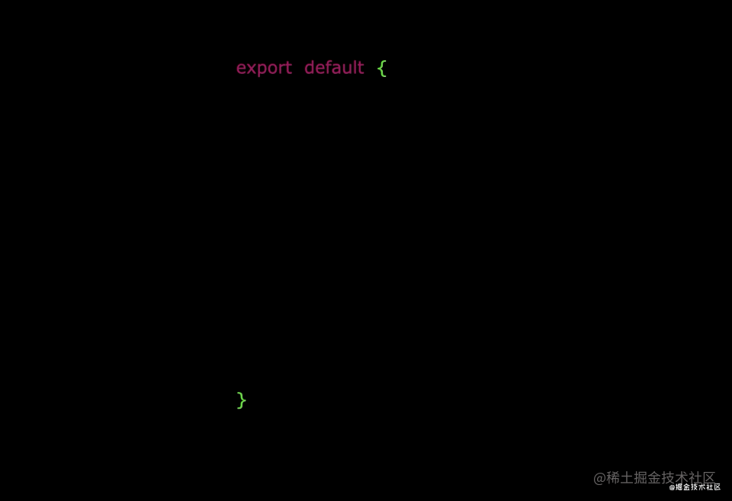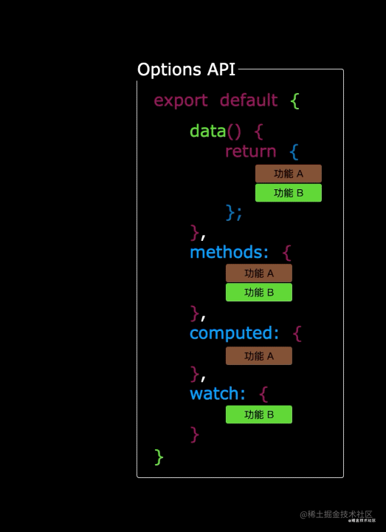

2、Composition API 的优势
我们可以更加优雅的组织我们的代码，函数。让相关功能的代码更加有序的组织在一起。
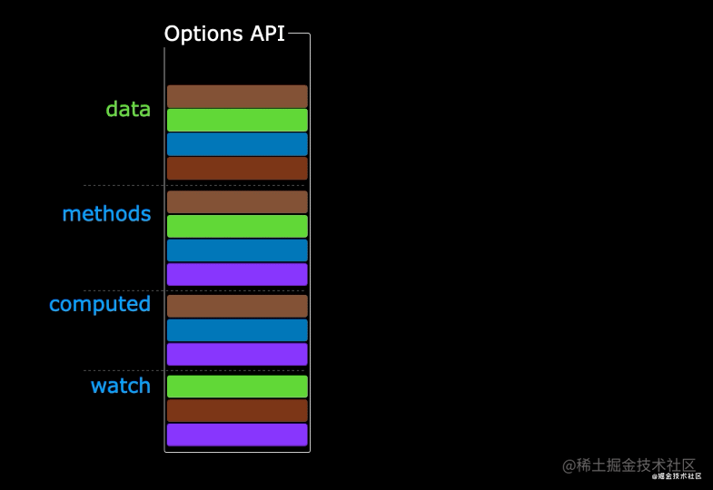
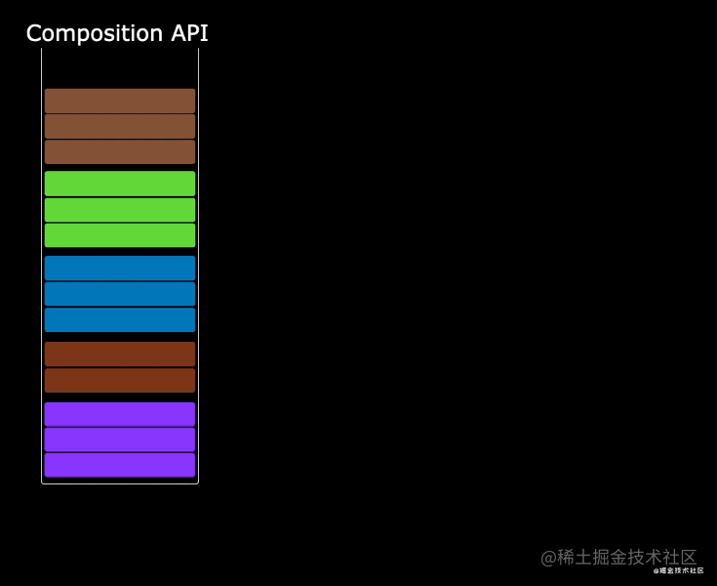

六、新的组件

1、Fragment
- 在 Vue2 中：组件必须有一个根标签
- 在 Vue3 中：组件可以没有根标签，内部会将多个标签包含在一个 Fragment 虚拟元素中
- 好处：减少标签层级，减小内存占用

2、Teleport
- 什么是 Teleport：Teleport 是一种能够将我们的组件 html 结构移动到指定位置的技术。
- 可以使元素的定位更加方便
// 引入的不再是 Vue 构造函数了，而是一个名为 createApp 的工厂函数
import { createApp } from 'vue'
// 引入 app 组件，他是所有组件的父组件
import App from './App.vue'
// 创建应用实例对象并挂载：app(类似于之前 Vue2 中的 vm，但 app 比 vm 更“轻”)
createApp(App).mount('#app')
<template>
<div class="app">
<h2>app 组件</h2>
<Child />
</div>
</template>
<script>
// 引入组件
import Child from '@/components/Child.vue'
export default {
name: 'App',
components: { Child }
}
</script>
<style>
.app{
background-color: skyblue;
padding: 10px;
}
.child{
background-color: coral;
padding: 10px;
}
.son{
background-color: lightpink;
padding: 10px;
}
</style>
<template>
<div class="child">
<h2>Child 组件</h2>
<Son/>
</div>
</template>
<script>
// 引入组件
import Son from '@/components/Son.vue'
export default {
// eslint-disable-next-line vue/multi-word-component-names
name: "Child",
components: { Son }
}
</script>
<template>
<div class="son">
<h2>Son 组件</h2>
<DiaLog/>
</div>
</template>
<script>
// 引入组件
import DiaLog from '@/components/DiaLog.vue'
export default {
// eslint-disable-next-line vue/multi-word-component-names
name: "Son",
components: { DiaLog }
}
</script>
<template>
<div>
<button @click="isShow = true">点我弹窗</button>
<!-- 将组件 html 结构移动到指定位置，body 下 -->
<Teleport to="body">
<!-- 遮罩层 -->
<div class="mask" v-if="isShow">
<!-- 弹窗 -->
<div class="dialog">
<h3>我是一个弹窗</h3>
<h4>月海</h4>
<h4>月海</h4>
<h4>月海</h4>
<button @click="isShow =false">关闭弹窗</button>
</div>
</div>
</Teleport>
</div>
</template>
<script>
// 引入 vue 函数
import { ref } from 'vue'
export default {
name: "DiaLog",
setup(){
let isShow = ref(false)
return { isShow }
}
}
</script>
<style scoped>
.mask{
position: absolute;
top: 0; bottom: 0; left: 0; right: 0;
background-color: rgba(0, 0, 0, 0.5);
}
.dialog{
background-color: olivedrab;
padding: 10px;
position: absolute;
top: 50%;
left: 50%;
transform: translate(-50%, -50%);
text-align: center;
width: 300px;
height: 300px;
}
</style>

3、Suspense
- 等待异步组件时渲染一些额外内容，让应用有更好的用户体验
- 使用步骤：
  - 异步引入组件
import {defineAsyncComponent} from 'vue'
const Child = defineAsyncComponent(()=>import('./components/Child.vue'))
  - 使用 Suspense 包裹组件，并配置好 default 与 fallback
<template>
<div class="app">
<h3>我是App组件</h3>
<Suspense>
<template v-slot:default>
<Child/>
</template>
<template v-slot:fallback>
<h3>加载中.....</h3>
</template>
</Suspense>
</div>
</template>

// 引入的不再是 Vue 构造函数了，而是一个名为 createApp 的工厂函数
import { createApp } from 'vue'
// 引入 app 组件，他是所有组件的父组件
import App from './App.vue'
// 创建应用实例对象并挂载：app(类似于之前 Vue2 中的 vm，但 app 比 vm 更“轻”)
createApp(App).mount('#app')
<template>
<div class="app">
<h2>app 组件</h2>
<!-- Suspense：等待异步组件时渲染一些额外内容 -->
<Suspense>
<!-- v-slot:default：需要加载的组件 -->
<template v-slot:default>
<Child />
</template>
<!-- v-slot:fallback：等待组件加载时显示的内容 -->
<template v-slot:fallback>
加载中。。。请稍后
</template>
</Suspense>
</div>
</template>
<script>
// 引入 vue 函数，defineAsyncComponent：异步引入
import { defineAsyncComponent } from 'vue'
const Child = defineAsyncComponent(()=>import('@/components/Child.vue'))
// 引入组件，静态引入
// import Child from '@/components/Child.vue'
export default {
name: 'App',
components: { Child }
}
</script>
<style>
.app{
background-color: skyblue;
padding: 10px;
}
.child{
background-color: coral;
padding: 10px;
}
</style>
<template>
<div class="child">
<h2>Child 组件</h2>
</div>
</template>
<script>
export default {
// eslint-disable-next-line vue/multi-word-component-names
name: "Child"
}
</script>

4、

七、其他改变

1、全局 API 的转移
- Vue 2.x 有许多全局 API 和配置。
- 例如：注册全局组件、注册全局指令等。
// 注册全局组件
Vue.component('MyButton', {
data: () => ({
count: 0
}),
template: '<button @click="count++">Clicked {{ count }} times.</button>'
})
// 注册全局指令
Vue.directive('focus', {
inserted: el => el.focus()
}
- Vue3.0 中对这些 API 做出了调整
- 将全局的 API，即：Vue.xxx 调整到应用实例（app）上
2.x 全局 API（Vue） | 3.x 实例 API (app)
Vue.config.xxxx | app.config.xxxx
Vue.config.productionTip | 移除
Vue.component | app.component
Vue.directive | app.directive
Vue.mixin | app.mixin
Vue.use | app.use
Vue.prototype | app.config.globalProperties

2、其他改变
- data 选项应始终被声明为一个函数。
- 过度类名的更改：
  - Vue2.x 写法
.v-enter,
.v-leave-to {
opacity: 0;
}
.v-leave,
.v-enter-to {
opacity: 1;
}
  - Vue3x 写法
.v-enter,
.v-leave-to {
opacity: 0;
}
.v-leave,
.v-enter-to {
opacity: 1;
}
- 移除 keyCode 作为 v-on 的修饰符，同时也不再支持 config.keyCodes
- 移除 v-on.native 修饰符
  - 父组件中绑定事件
<my-component
v-on:close="handleComponentEvent"
v-on:click="handleNativeClickEvent"
/>
  - 子组件中声明自定义事件
<script>
export default {
emits: ['close']
}
</script>
- 移除过滤器（filter）
过滤器虽然这看起来很方便，但它需要一个自定义语法，打破大括号内表达式是 “只是 JavaScript” 的假设，这不仅有学习成本，而且有实现成本！建议用方法调用或计算属性去替换过滤器。
- ......

4、

5、

6、

八、追加

1、使用 svg
阿里巴巴矢量图标库：https://www.iconfont.cn/
- 进入网站，选择矢量图
- 点击下载，可下载 SVG 文件或者 SVG 代码
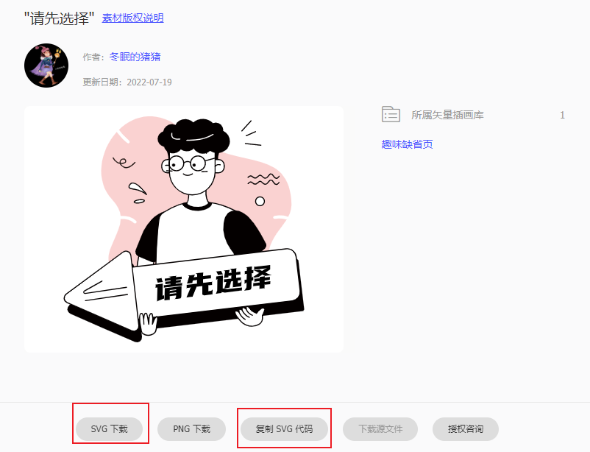

①、直接使用
- 复制 SVG 代码
- 粘贴到 vue 组件中
- 将 <style></style> 标签中的样式移动到 vue 的 <style></style> 标签中
- 删除 <defs></defs> 标签，即可使用
<template>
<svg viewBox="0 0 1024 1024" xmlns="http://www.w3.org/2000/svg" id="b52015b4-2459-46df-970a-a6cd264bdde9">
<title>党建1024px尺寸</title>
<rect height="1024" width="1024" class="bd557e99-0b60-410e-9190-ab39419af894"></rect>
<path d="M892.19,468.81a6.4,6.4,0,0,1-2.87-12.48c1.71-.39,30.78-6.8,57.52,3.93,10-19.51,15.95-41.22,13.34-68.57C937.69,155.37,715.46,279.07,512.3,101.94c-102.19-89.1-203.12-67.57-268.64-3.67,12.66,18.83,31.68,36.7,42.36,45.3a6.4,6.4,0,0,1-8,10A270.16,270.16,0,0,1,242.43,118q-4.32-5.28-7.87-10.34c-70.65,77.13-93.35,205-17.69,283.08,21.76,22.47,31.31,44.24,33.46,65.51,25.26-.61,49.85,4.24,64.92,21a6.4,6.4,0,1,1-9.52,8.56c-12.19-13.54-33-17.5-55-16.89C247.4,586.07,45.29,689.44,470,816.65c213.73,64,320.93,33.34,364.64-46,43.41-78.83,18.26-98.79,32.05-169.25,11.26-57.6,49.61-90.25,73.73-129.75C917.6,463.19,892.55,468.73,892.19,468.81Z"
class="a54ce527-3476-4590-b6a3-daf0baba896f"></path>
<path d="M445.95,222.22h36.11a0,0,0,0,1,0,0v55.21a0,0,0,0,1,0,0H445.95A24.41,24.41,0,0,1,421.53,253v-6.38a24.41,24.41,0,0,1,24.41-24.41Z"
class="ec866187-f413-49ef-aca1-b2c926a96c4c"></path>
<path d="M482.06,279.56H445.22a25.85,25.85,0,0,1-25.82-25.82v-7.83a25.85,25.85,0,0,1,25.82-25.82h36.84a2.13,2.13,0,0,1,2.13,2.13v55.21A2.13,2.13,0,0,1,482.06,279.56Zm-36.84-55.21a21.58,21.58,0,0,0-21.55,21.56v7.83a21.58,21.58,0,0,0,21.55,21.55h34.71V224.35Z"
class="e1c3efd2-ec07-48e8-9f5a-049331813ab8"></path>
<path d="M437.16,246.55s17.11-3.73,22.44,7.16" class="ec866187-f413-49ef-aca1-b2c926a96c4c"></path>
<path d="M459.6,255.85a2.12,2.12,0,0,1-1.91-1.2c-4.55-9.28-19.92-6.05-20.07-6a2.13,2.13,0,1,1-.91-4.16c.76-.17,18.81-3.95,24.81,8.3a2.14,2.14,0,0,1-1,2.86A2.09,2.09,0,0,1,459.6,255.85Z"
class="e1c3efd2-ec07-48e8-9f5a-049331813ab8"></path>
<path d="M332.29,593.16S311,678.51,317.59,720.67s51,22.29,51,22.29L395.9,613.49l-67.83-19.67"
class="ec866187-f413-49ef-aca1-b2c926a96c4c"></path>
<path d="M346.64,749.79a33,33,0,0,1-15.85-3.66c-8.26-4.49-13.42-13-15.31-25.13-5.84-37.56,9.77-107.47,13.83-124.6l-1.83-.54a2.13,2.13,0,1,1,1.19-4.09l1.69.49a2.13,2.13,0,0,1,4.05,1.17l62.09,18a2.13,2.13,0,0,1,1.49,2.49L370.64,743.41a2.13,2.13,0,0,1-1.22,1.5A62.14,62.14,0,0,1,346.64,749.79Zm-13.22-152.2c-4,17.19-19.35,86.6-13.73,122.75,1.68,10.8,6.1,18.21,13.12,22,12.38,6.75,29.62.73,33.89-1L393.41,615Z"
class="e1c3efd2-ec07-48e8-9f5a-049331813ab8"></path>
<path d="M439.67,436s-56.4,7.71-93.12,81.48c-13.84,27.81-23.65,58.87-32.77,77.8a22.12,22.12,0,0,0,11.62,30.09l52.89,21.52a22.15,22.15,0,0,0,28.63-11.63l34.64-79.12Z"
class="e1c3efd2-ec07-48e8-9f5a-049331813ab8"></path>
<path d="M644.74,404.62a245.08,245.08,0,0,0-58.61-5.74H555.21c-43.81-.85-87.52,18-126.43,42.89a41.54,41.54,0,0,0-18.87,29.16c-6,41.91-18.12,158.8-12.63,391,0,0,258.89,12.8,361.29-25.6L719.21,587.27,750,448.09c-23.87-17.07-72.12-36-105.3-43.47"
class="ec866187-f413-49ef-aca1-b2c926a96c4c"></path>
<path d="M493.66,866.07c-55,0-95.47-1.93-96.49-2a2.14,2.14,0,0,1-2-2.08c-5.53-234.23,7-351.73,12.66-391.38A43.73,43.73,0,0,1,427.63,440c46.08-29.44,89.08-44,127.63-43.22h30.85a249.59,249.59,0,0,1,59.1,5.78c31.37,7,80.84,25.78,106.07,43.83a2.11,2.11,0,0,1,.84,2.19L721.38,587.33,760.68,836a2.13,2.13,0,0,1-1.36,2.33C697.66,861.48,578.45,866.07,493.66,866.07Zm-94.3-6.15C423.46,861,659,870.3,756.19,835L717.1,587.6a2.1,2.1,0,0,1,0-.79L747.65,449c-25.13-17.49-72.88-35.5-103.37-42.32a245.11,245.11,0,0,0-58-5.69h-31c-38-.76-79.94,13.58-125.28,42.56A39.45,39.45,0,0,0,412,471.23C406.41,510.66,394,627.35,399.36,859.92Z"
class="e1c3efd2-ec07-48e8-9f5a-049331813ab8"></path>
<path d="M850.47,591.22l-74.11,66.25a16.69,16.69,0,0,1-24.53-2.53l-45-60.84c-22.81-30.83-33.63-69.25-28.57-107.26,3.4-25.54,13.95-47.5,39.51-52,64-11.41,117.41,99.55,136.45,136.28A16.7,16.7,0,0,1,850.47,591.22Z"
class="e1c3efd2-ec07-48e8-9f5a-049331813ab8"></path>
<polygon
points="785.54 635.83 841.01 576.09 823.94 537.69 785.54 537.69 759.94 567.56 759.94 593.16 785.54 635.83"
class="e1c3efd2-ec07-48e8-9f5a-049331813ab8"></polygon>
<path d="M438.57,174.74s14.21,37.9,9.48,47.38c0,0,4.73-4.74,14.21,0V189Z"
class="e1c3efd2-ec07-48e8-9f5a-049331813ab8"></path>
<path d="M533.27,359.24s3.15,27.63-7.78,44.71c-5,7.8-1,18.22,7.75,21.32,18.55,6.58,48,11,81.29-6.7a10,10,0,0,0,3.23-15c-7-8.95-15.26-26.54-12.13-58.23Z"
class="ec866187-f413-49ef-aca1-b2c926a96c4c"></path>
<path d="M566.33,433.17a101.24,101.24,0,0,1-33.8-5.89,17,17,0,0,1-10.46-10.56,16,16,0,0,1,1.62-13.92c10.39-16.23,7.5-43.05,7.46-43.32a2.15,2.15,0,0,1,1.72-2.34l72.36-13.93a2.1,2.1,0,0,1,1.84.52,2.16,2.16,0,0,1,.69,1.78c-3,30.64,4.68,47.75,11.68,56.7a12.19,12.19,0,0,1-3.91,18.25C597.71,429.89,581,433.17,566.33,433.17ZM535.57,361c.51,6.76,1.34,29.1-8.29,44.13a11.78,11.78,0,0,0-1.17,10.23,12.78,12.78,0,0,0,7.84,7.93c18.35,6.51,47.06,10.64,79.59-6.58a7.91,7.91,0,0,0,2.54-11.84c-7.26-9.28-15.25-26.63-12.83-56.91Z"
class="e1c3efd2-ec07-48e8-9f5a-049331813ab8"></path>
<path transform="translate(1301.48 499.65) rotate(180)"
d="M642.37,222.22H681a0,0,0,0,1,0,0v55.21a0,0,0,0,1,0,0H646a25.55,25.55,0,0,1-25.55-25.55v-7.77a21.89,21.89,0,0,1,21.89-21.89Z"
class="ec866187-f413-49ef-aca1-b2c926a96c4c"></path>
<path d="M657.31,279.56H620.48a2.13,2.13,0,0,1-2.14-2.13V222.22a2.13,2.13,0,0,1,2.14-2.13h36.83a25.85,25.85,0,0,1,25.83,25.82v7.83A25.85,25.85,0,0,1,657.31,279.56Zm-34.7-4.27h34.7a21.58,21.58,0,0,0,21.56-21.55v-7.83a21.58,21.58,0,0,0-21.56-21.56h-34.7Z"
class="e1c3efd2-ec07-48e8-9f5a-049331813ab8"></path>
<path d="M525.86,130.65h44.46a72.62,72.62,0,0,1,72.62,72.62v70.87A94.85,94.85,0,0,1,548.09,369h0a94.85,94.85,0,0,1-94.85-94.85V203.27A72.62,72.62,0,0,1,525.86,130.65Z"
class="ec866187-f413-49ef-aca1-b2c926a96c4c"></path>
<path d="M548.09,371.12a97.08,97.08,0,0,1-97-97V130.65a2.13,2.13,0,0,1,2.13-2.13h189.7a2.13,2.13,0,0,1,2.13,2.13V274.14A97.09,97.09,0,0,1,548.09,371.12ZM455.37,132.79V274.14a92.72,92.72,0,1,0,185.44,0V132.79Z"
class="e1c3efd2-ec07-48e8-9f5a-049331813ab8"></path>
<path d="M676.45,102.77c.11-.85.21-1.71.25-2.59.72-16.45-12.91-30.41-30.45-31.19a33.66,33.66,0,0,0-12.36,1.77c-9.24-9.8-23.44-16.41-39.63-17.12-16.68-.73-31.8,5-41.86,14.41A47.16,47.16,0,0,0,521,54.43c-18.78-.82-35.36,9.11-43,24a34.49,34.49,0,0,0-13.45-3.38c-17.92-.79-33.35,12.26-37,30.1-13.1,5.23-22.43,16.57-23,30.12-.69,15.6,10.38,29.32,26.26,34.51a39.26,39.26,0,0,0,69.4,10.43,44.06,44.06,0,0,0,23.21,7.88,44.52,44.52,0,0,0,31.35-11.16c7.8,12.32,20.67,20.67,35.6,21.33a43.68,43.68,0,0,0,31.31-11.58,55.76,55.76,0,0,0,27.7,8.73c29.29,1.29,54-19.74,55.2-47C705.39,128.9,693.85,111.52,676.45,102.77Z"
class="e1c3efd2-ec07-48e8-9f5a-049331813ab8"></path>
<path d="M464.17,272.26h-.11L441.53,271a2.13,2.13,0,0,1-2-2.24,2.06,2.06,0,0,1,2.24-2L464.29,268a2.13,2.13,0,0,1-.12,4.26Z"
class="e1c3efd2-ec07-48e8-9f5a-049331813ab8"></path>
<path d="M587.91,275.29a2.13,2.13,0,0,1-.12-4.26l22.52-1.23a2,2,0,0,1,2.25,2,2.13,2.13,0,0,1-2,2.24L588,275.29Z"
class="e1c3efd2-ec07-48e8-9f5a-049331813ab8"></path>
<path d="M482.17,271A32.93,32.93,0,1,1,515.1,238.1,33,33,0,0,1,482.17,271Zm0-61.6a28.67,28.67,0,1,0,28.66,28.67A28.69,28.69,0,0,0,482.17,209.43Z"
class="e1c3efd2-ec07-48e8-9f5a-049331813ab8"></path>
<path d="M571.77,271A32.93,32.93,0,1,1,604.7,238.1,33,33,0,0,1,571.77,271Zm0-61.6a28.67,28.67,0,1,0,28.66,28.67A28.69,28.69,0,0,0,571.77,209.43Z"
class="e1c3efd2-ec07-48e8-9f5a-049331813ab8"></path>
<path d="M540.16,236.89a2.16,2.16,0,0,1-1.42-.54c-9.2-8.25-21.66-.16-22.19.19a2.14,2.14,0,0,1-2.36-3.56c5.39-3.59,18-8.18,27.4.19a2.13,2.13,0,0,1-1.43,3.72Z"
class="e1c3efd2-ec07-48e8-9f5a-049331813ab8"></path>
<path d="M488.08,139.94c-11.06,0-18.9-2.77-23.37-8.27-6.55-8.07-3.16-18.74-3-19.19a2.14,2.14,0,0,1,4.06,1.33c0,.09-2.81,9,2.28,15.19,4.57,5.6,14.47,7.74,28.62,6.16a2.1,2.1,0,0,1,2.35,1.89,2.13,2.13,0,0,1-1.88,2.35A81.76,81.76,0,0,1,488.08,139.94Z"
class="bf745ff3-d487-4892-9840-f9bc03550fe1"></path>
<path d="M535.18,144.42c-6.19,0-9.87-.26-10-.27a2.14,2.14,0,0,1,.32-4.26c.61.05,61.48,4.35,107.71-23.39a2.14,2.14,0,1,1,2.2,3.66C599.35,141.78,554.77,144.42,535.18,144.42Z"
class="bf745ff3-d487-4892-9840-f9bc03550fe1"></path>
<path d="M528.76,290.1c-12.07,0-19.06-6.79-19.16-6.9a2.13,2.13,0,0,1,3-3c.56.55,13.45,12.8,35.3-.32a2.13,2.13,0,1,1,2.19,3.66C541.9,288.44,534.71,290.1,528.76,290.1Z"
class="e1c3efd2-ec07-48e8-9f5a-049331813ab8"></path>
<path d="M464.2,195.4a2.12,2.12,0,0,1-1.77-3.31c.1-.16,10.56-15.52,26.13-10.32a2.13,2.13,0,1,1-1.35,4c-12.52-4.18-21.15,8.5-21.23,8.63A2.14,2.14,0,0,1,464.2,195.4Z"
class="e1c3efd2-ec07-48e8-9f5a-049331813ab8"></path>
<path d="M607.33,198.49a2.13,2.13,0,0,1-2.07-1.61c0-.07-1.86-7-7.41-9.58-3.56-1.63-8-1.13-13.26,1.49a2.13,2.13,0,1,1-1.9-3.82c6.46-3.23,12.18-3.74,17-1.54,7.41,3.41,9.65,12,9.74,12.41a2.13,2.13,0,0,1-1.55,2.58A1.91,1.91,0,0,1,607.33,198.49Z"
class="e1c3efd2-ec07-48e8-9f5a-049331813ab8"></path>
<path d="M274.39,258a27.07,27.07,0,0,1-12.7-3.16c-8.21-4.25-12.65-9.51-14.57-14.57-20.07-3.76-29.48-24-29.58-24.28a2.13,2.13,0,0,1,3.88-1.76c.39.85,8.12,17.39,24.62,21.46a15.93,15.93,0,0,1,.45-5.7c2-7.56,9.28-12.59,17.7-12.19,4.94.22,9.46,5.06,9.67,10.35.09,2.45-.75,10.59-15.54,12.42a36.76,36.76,0,0,1-6.23.26c1.95,3.53,5.59,7.13,11.56,10.23,22,11.41,44.91-18.36,45.14-18.67a2.13,2.13,0,0,1,3.4,2.58C311.34,236.08,294.47,258,274.39,258Zm-23.93-21.55a33.63,33.63,0,0,0,7.34-.12c7.66-.95,12-3.87,11.79-8-.12-3.09-2.84-6.13-5.6-6.26-6.42-.32-11.88,3.43-13.38,9A11.93,11.93,0,0,0,250.46,236.44Z"
class="a635c0bf-c78a-49dd-bca9-cad7ca5aedca"></path>
<circle r="18.44" cy="395.68" cx="829.65" class="ec866187-f413-49ef-aca1-b2c926a96c4c"></circle>
<path d="M829.65,416.26a20.58,20.58,0,1,1,20.57-20.58A20.6,20.6,0,0,1,829.65,416.26Zm0-36.89A16.31,16.31,0,1,0,846,395.68,16.33,16.33,0,0,0,829.65,379.37Z"
class="e1c3efd2-ec07-48e8-9f5a-049331813ab8"></path>
<circle r="6.23" cy="245.25" cx="470.74" class="e1c3efd2-ec07-48e8-9f5a-049331813ab8"></circle>
<circle r="6.23" cy="245.25" cx="556.08" class="e1c3efd2-ec07-48e8-9f5a-049331813ab8"></circle>
<path d="M357.84,367.36s-46.93-67.49-68.26-41.89c-14,16.79,6.81,18.61,17.05,20a113.51,113.51,0,0,1,18.15,4C334.86,352.7,348.34,358.29,357.84,367.36Z"
class="ec866187-f413-49ef-aca1-b2c926a96c4c"></path>
<path d="M357.84,369.49a2.13,2.13,0,0,1-1.47-.59c-9.3-8.88-22.66-14.33-32.23-17.33a109.87,109.87,0,0,0-17.8-3.94l-1.61-.22c-7.93-1.07-18.79-2.54-21.42-9.3-1.51-3.88,0-8.46,4.63-14a17,17,0,0,1,14.35-6.55c24,1.05,55.95,46.64,57.3,48.58a2.13,2.13,0,0,1-1.75,3.35Zm-56.4-47.68a12.76,12.76,0,0,0-10.23,5c-2.39,2.88-5,6.9-3.92,9.72,1.71,4.42,11.91,5.8,18,6.63l1.63.22a113.68,113.68,0,0,1,18.49,4.09,108.49,108.49,0,0,1,21.7,9.34c-11.09-13.64-30.3-34.37-45-35Z"
class="e1c3efd2-ec07-48e8-9f5a-049331813ab8"></path>
<ellipse transform="translate(-50.29 47.73) rotate(-7.73)" ry="6.4" rx="21.33" cy="395.87" cx="327.98"
class="ec866187-f413-49ef-aca1-b2c926a96c4c"></ellipse>
<path d="M320.05,405a44.74,44.74,0,0,1-6.74-.47c-5.32-.84-8.21-2.68-8.58-5.47h0c-.79-5.81,10.9-10.09,22.1-11.61a57.37,57.37,0,0,1,15.82-.17c5.32.84,8.21,2.68,8.58,5.47.79,5.81-10.9,10.09-22.1,11.61A67.75,67.75,0,0,1,320.05,405ZM309,398.46c.59,1.13,7.33,3.3,19.59,1.64s18.29-5.63,18.45-6.84c-.47-1.07-7.21-3.3-19.59-1.61S309.22,397.2,309,398.46Z"
class="e1c3efd2-ec07-48e8-9f5a-049331813ab8"></path>
<path d="M664.7,179.29s-12.8,34.14-8.53,42.67c0,0-4.27-4.27-12.8,0V192.09Z"
class="e1c3efd2-ec07-48e8-9f5a-049331813ab8"></path>
<path d="M897.37,302.36c-4.78,0-9.17-3.36-13.07-10-3.09-5.24-6.25-8-9.14-8.08h-.06c-3.64,0-6.74,4.3-7.9,6.16a29.27,29.27,0,0,1-6.45,7.6c-7.45,5.85-15.35,4.85-21.69-2.76-3.14-3.77-6.14-5.68-8.91-5.68s-4.94,1.91-6.27,3.52c-3,3.58-5.89,5.9-8.89,7.09-4.29,1.7-10.74,2.36-17-4.22-2.5-2.61-5-3.84-7.56-3.58-4.92.44-8.62,6-8.66,6a2.13,2.13,0,0,1-3.57-2.34c.19-.3,4.85-7.3,11.81-7.94,3.9-.36,7.62,1.28,11.06,4.88,3.74,3.91,7.92,5,12.39,3.2,2.32-.92,4.68-2.83,7.19-5.85,1.92-2.31,5.13-5.06,9.54-5.06h0c4.1,0,8.2,2.43,12.19,7.22,4.92,5.91,10.08,6.61,15.78,2.13a25,25,0,0,0,5.47-6.51c1.93-3.08,6.15-8.14,11.64-8.15,4.52.06,8.81,3.49,12.74,10.18,3.08,5.23,6.24,7.89,9.41,7.89h.06c4.56,0,8.75-5.74,10-7.93a2.13,2.13,0,0,1,3.73,2.07c-.23.42-5.68,10-13.65,10.12Z"
class="e1c3efd2-ec07-48e8-9f5a-049331813ab8"></path>
<path d="M897.37,327.67c-4.78,0-9.17-3.36-13.07-10-3.09-5.25-6.25-8-9.14-8.08h-.06c-3.64,0-6.74,4.3-7.9,6.15a29.27,29.27,0,0,1-6.45,7.6c-7.45,5.86-15.35,4.85-21.69-2.76-3.14-3.77-6.14-5.68-8.91-5.68s-4.94,1.92-6.27,3.52c-3,3.58-5.89,5.9-8.89,7.09-4.29,1.7-10.74,2.37-17-4.22-2.5-2.6-5-3.82-7.56-3.58-4.92.44-8.62,6-8.66,6a2.13,2.13,0,0,1-3.57-2.33c.19-.3,4.85-7.3,11.81-7.95,3.9-.36,7.62,1.29,11.06,4.88,3.74,3.91,7.92,5,12.39,3.21,2.32-.92,4.68-2.84,7.19-5.86,1.92-2.3,5.13-5.05,9.54-5.05h0c4.1,0,8.2,2.42,12.19,7.21,4.92,5.91,10.08,6.62,15.78,2.14a25.19,25.19,0,0,0,5.47-6.52c1.93-3.07,6.15-8.25,11.64-8.15,4.52.07,8.81,3.49,12.74,10.19,3.08,5.23,6.24,7.88,9.41,7.88h.06c4.56,0,8.75-5.74,10-7.93a2.14,2.14,0,0,1,3.73,2.08c-.23.41-5.68,10-13.65,10.12Z"
class="e1c3efd2-ec07-48e8-9f5a-049331813ab8"></path>
<path d="M643.37,254a2.27,2.27,0,0,1-.62-.09,2.14,2.14,0,0,1-1.42-2.67c0-.13,4.34-13.44,23.83-9.2a2.13,2.13,0,1,1-.91,4.17c-15.68-3.44-18.81,6.18-18.84,6.28A2.13,2.13,0,0,1,643.37,254Z"
class="e1c3efd2-ec07-48e8-9f5a-049331813ab8"></path>
<path d="M572.84,418.61c-26.78,1.08-41.24-6.35-48.94-17.45-4.26,0-17.2,1.18-17.06,4.27.68,15.16,33.43,31.08,66,29.78s58.4-17.31,57.72-32.48c-.09-2-6.08-2.06-9.9-2.92a5.12,5.12,0,0,0-5.17,1.78C608,411.08,596.26,417.68,572.84,418.61Z"
class="e1c3efd2-ec07-48e8-9f5a-049331813ab8"></path>
<rect transform="translate(-88.61 79.51) rotate(-6.78)" rx="8.78" height="217.6" width="755.2" y="678.39"
x="248.8" class="e1c3efd2-ec07-48e8-9f5a-049331813ab8"></rect>
<path d="M273.3,652.83a20.79,20.79,0,0,1,33,14.36l16.54,145.56L339.39,958.3a20.78,20.78,0,0,1-28.94,21.41L176.13,921.26,41.8,862.81A20.78,20.78,0,0,1,37.74,827l117.78-87.11Z"
class="e1c3efd2-ec07-48e8-9f5a-049331813ab8"></path>
<path transform="translate(-83.26 77.63) rotate(-6.78)"
d="M244.37,632.3H982a8.78,8.78,0,0,1,8.78,8.78V807.91a42,42,0,0,1-42,42H244.37a8.78,8.78,0,0,1-8.78-8.78v-200a8.78,8.78,0,0,1,8.78-8.78Z"
class="ec866187-f413-49ef-aca1-b2c926a96c4c"></path>
<path d="M283.84,891.71a39.66,39.66,0,0,1-39.3-34.93L227.69,715.14a39.59,39.59,0,0,1,34.65-44l675.48-80.36a39.67,39.67,0,0,1,44,34.66l16.85,141.64a39.61,39.61,0,0,1-34.66,44L288.55,891.43A39.53,39.53,0,0,1,283.84,891.71Zm658.68-297a35.29,35.29,0,0,0-4.2.25L262.84,675.36a35.35,35.35,0,0,0-30.92,39.27l16.85,141.64A35.37,35.37,0,0,0,288,887.2l675.48-80.37a35.34,35.34,0,0,0,30.93-39.27L977.6,625.92A35.41,35.41,0,0,0,942.52,594.75Z"
class="e1c3efd2-ec07-48e8-9f5a-049331813ab8"></path>
<path d="M260.08,606.74a20.79,20.79,0,0,1,33,14.36l16.55,145.56,16.54,145.55a20.78,20.78,0,0,1-28.94,21.41L162.91,875.17,28.58,816.72A20.79,20.79,0,0,1,24.52,781L142.3,693.84Z"
class="ec866187-f413-49ef-aca1-b2c926a96c4c"></path>
<path d="M305.59,937.51a22.93,22.93,0,0,1-9.2-1.94L27.74,818.67a22.92,22.92,0,0,1-4.49-39.44L258.82,605a22.91,22.91,0,0,1,36.39,15.84L328.3,912a23,23,0,0,1-22.71,25.54ZM272.4,604.77a18.56,18.56,0,0,0-11,3.68L25.79,782.66a18.65,18.65,0,0,0,3.65,32.1l268.65,116.9a18.65,18.65,0,0,0,26-19.21L291,621.35a18.75,18.75,0,0,0-18.57-16.58Z"
class="e1c3efd2-ec07-48e8-9f5a-049331813ab8"></path>
<path d="M845.06,839.08c8.53,4.27,5.33,7.21-5.42,31.41,0,.07,0,4.27,0,12.8,0,14.41-11.42,24-25.19,28.2l-.41.13c-42.67,12.8-67.12-21.34-67.12-21.34S725.59,869,725.59,856.15s17.07,0,17.07,0c-4.27-21.33,12.8-8.53,12.8-8.53-4.27-21.34,17.06-4.27,17.06-4.27-4.26-17.07,8.54-12.8,17.07,0,7,10.46,25.6,17.07,25.6,17.07S834.26,833.69,845.06,839.08Z"
class="ec866187-f413-49ef-aca1-b2c926a96c4c"></path>
<path d="M795.37,916.6c-31.79,0-50-24.78-50.18-25.08-.67-.62-21.73-21.84-21.73-35.37,0-4.47,1.89-6.36,3.48-7.15,3.7-1.85,9.16.54,12.95,2.77-.3-4.64.73-7.66,3.12-9.17,2.93-1.84,6.83-.62,9.77.86-.16-3.91.86-6.49,3.07-7.83,3.77-2.3,9.66.47,13.74,3-.33-5.23,1.59-7.37,3.52-8.22,5.3-2.34,13.19,4.13,18.25,11.73,5.4,8.09,18.64,13.9,23.07,15.67,4.45-6,20.58-26.16,31.58-20.67,9.1,4.55,7,9.22-.12,24.69-1.21,2.64-2.59,5.66-4.13,9.11v12.32c0,13.83-10,25.14-26.7,30.24l-.41.13A67.13,67.13,0,0,1,795.37,916.6Zm-65.33-64a2.72,2.72,0,0,0-1.19.23c-.93.47-1.13,2.07-1.13,3.34,0,9.77,14.95,26.86,20.71,32.62,1.19,1.61,24.33,33,65,20.8l.43-.13c14.79-4.51,23.65-14.29,23.65-26.15v-8.51c0-4.69,0-4.69.19-5.14,1.62-3.65,3.06-6.81,4.32-9.56,7.5-16.38,7.2-16.54,2.09-19.09h0c-6.65-3.34-20.21,10.91-27.17,20.67a2.14,2.14,0,0,1-2.45.77c-.79-.28-19.38-7-26.67-17.9-5.07-7.62-11-11.08-13-10.19-.8.35-1.74,2.53-.25,8.49a2.14,2.14,0,0,1-3.4,2.19c-4.08-3.27-10.93-7.1-13.13-5.75-.44.27-1.77,1.63-.51,7.93a2.13,2.13,0,0,1-3.37,2.12c-2.65-2-7.21-4.16-8.89-3.11-.51.32-2,2-.54,9.52a2.14,2.14,0,0,1-3.37,2.13C738.23,855.5,733,852.58,730,852.58Z"
class="e1c3efd2-ec07-48e8-9f5a-049331813ab8"></path>
<path d="M772.52,843.35s4.27,17.07,25.6,25.6" class="ec866187-f413-49ef-aca1-b2c926a96c4c"></path>
<path d="M798.12,871.08a2.21,2.21,0,0,1-.79-.15c-22.09-8.84-26.69-26.32-26.88-27.06a2.15,2.15,0,0,1,1.55-2.59,2.11,2.11,0,0,1,2.59,1.55c.17.65,4.35,16.15,24.32,24.14a2.13,2.13,0,0,1-.79,4.11Z"
class="e1c3efd2-ec07-48e8-9f5a-049331813ab8"></path>
<path d="M755.46,847.62S764,869,785.32,877.48" class="ec866187-f413-49ef-aca1-b2c926a96c4c"></path>
<path d="M785.32,879.62a2,2,0,0,1-.79-.16c-21.93-8.77-30.69-30.15-31-31.05a2.13,2.13,0,0,1,4-1.59c.08.21,8.48,20.6,28.67,28.68a2.14,2.14,0,0,1-.79,4.12Z"
class="e1c3efd2-ec07-48e8-9f5a-049331813ab8"></path>
<path d="M742.66,856.15s8.53,21.33,25.6,29.87" class="ec866187-f413-49ef-aca1-b2c926a96c4c"></path>
<path d="M768.26,888.15a2.09,2.09,0,0,1-1-.23c-17.59-8.79-26.26-30.08-26.62-31a2.13,2.13,0,1,1,4-1.58c.08.2,8.45,20.69,24.57,28.75a2.13,2.13,0,0,1-1,4Z"
class="e1c3efd2-ec07-48e8-9f5a-049331813ab8"></path>
<path d="M337.39,936.38s-18.13-75.41,0-75.41c10.05,0,10.05,45.25,10.05,45.25S342.42,856,357.5,861c4.77,1.59,10.05,45.25,10.05,45.25S366.37,861,377.61,861c10.05,0,5,45.25,5,45.25s12.16-38.11,20.11-30.16c5,5-2.7,29.35-2.8,35-.31,17.31-2.23,35.34-27.36,40.37C362.51,953.47,342.42,951.46,337.39,936.38Z"
class="ec866187-f413-49ef-aca1-b2c926a96c4c"></path>
<path d="M365.45,954.23c-10.84,0-25.6-3.73-30.09-17.18a1.54,1.54,0,0,0-.05-.17c-1.51-6.29-14.47-61.84-4.16-74.92a7.74,7.74,0,0,1,6.24-3.12c1.71,0,5.72,1.22,8.67,11.54,1-4.61,2.59-8.39,5-10.32a7.23,7.23,0,0,1,7.1-1.11c3.14,1,5.89,11.21,8.12,23.71.94-8.95,2.82-17.86,6.5-21.64,2.65-2.71,6.52-3,9-.21,4.23,4.72,4.58,19.13,4.11,30.57,3.57-8.32,8.43-17.22,13.26-18.4a5.29,5.29,0,0,1,5.11,1.57c4,4,2.19,14.57-.64,27.93a68,68,0,0,0-1.54,8.65c-.32,18.59-2.83,37.17-29.08,42.42A39.41,39.41,0,0,1,365.45,954.23Zm-26-18.44c4.78,14.1,24.46,15.22,32.72,13.58,23.15-4.63,25.34-20.76,25.64-38.31a65.75,65.75,0,0,1,1.64-9.46c1.57-7.45,4.5-21.33,1.79-24-.56-.55-.88-.49-1.09-.43-4.48,1.09-11.75,18-15.48,29.74a2.13,2.13,0,0,1-4.15-.89c1.54-13.82,2.37-37.53-1.92-42.33a1.25,1.25,0,0,0-1-.54,2.37,2.37,0,0,0-1.77.89c-5.8,6-6.41,32.45-6.15,42.16a2.13,2.13,0,0,1-4.25.31c-2.33-19.24-6.39-41.39-8.89-43.61a2.87,2.87,0,0,0-2.82.53c-3.43,2.74-4.75,12.6-4.94,23.07.5,5.45.79,12,.79,19.76a2.14,2.14,0,0,1-4.26.21,187.33,187.33,0,0,1-.84-18.84c-1.24-13.63-3.79-24.48-7.09-24.48a3.49,3.49,0,0,0-2.89,1.49C326.86,874.29,335.46,919.18,339.44,935.79Z"
class="e1c3efd2-ec07-48e8-9f5a-049331813ab8"></path>
<path d="M402.17,810.73l1-57.07-7.15.87.28-13.19,29.52-3.6L424.91,788l6.26-2.64-.32,13.87Zm18-96,5.3,16-20.78,2.53-5.3-16Zm37.38,12.51v-3.35l-23.69,2.88.12-10.09,23.82-2.9,0-.94-5.36-4.32,28.46-3.47-.22,5.94,23.95-2.92-.11,10.09-24,2.92-.12,3.37,19.85-2.42-.23,10.24-19.72,2.4-.13,3.38,25.94-3.17-.22,10.24-75.58,9.21.23-10.24,26.6-3.24.13-3.37-20.91,2.55.23-10.24Zm18.34,74.47,5.07-8,.05-7.26-26.33,3.21-.23,14.67L432.74,807l1-50.49L503.46,748l-.84,41.6a13.37,13.37,0,0,1-1.61,6.58,6.45,6.45,0,0,1-5.13,3.11Zm-21-21.09,26.34-3.21.06-3.9L455,776.77Zm.17-12.92,26.34-3.21.1-3.63-26.34,3.2Z"></path>
<path d="M535.82,707.15l-3.77-3.44,26.34-3.21-3.28,10.61,13.1-1.6.25-10.1-5-4.5,30.18-3.67-.3,15.21,32.69-4-.19,12.78-32.82,4-.28,15.35L630.61,730l-.32,12.8-15.08,1.84-.4,24.36,12.58-1.53,5.07-5.72-.36,20.19L598.35,786a7.82,7.82,0,0,1-6.39-1.77,7.27,7.27,0,0,1-2.36-6.16l.46-30.42-23.43,2.86L549.12,792,524,795.09l17.52-41.49-16.81,2,.31-12.8,42.62-5.19L568,722.3,551,724.38,547.68,735l-21.31,2.6Z"></path>
<path d="M646.4,779.1l5.22-13.39.84-46.05-5,.62.19-12.78,27.66-3.37-.89,53.3,18.79,3.21,61.55-7.49-.19,12.78-70.42,8.58-13.43-2.26-1.65,4.1Zm21.8-94.53L675.46,699l-20.11,2.45L648.08,687Zm35.21-4.29L701,693.34l9.67-1.18.23-10.23-5-4.5L731,674.37l-.28,15.34,17.61-2.14L748.13,699l-17.6,2.15-.17,12.91,20.11-2.45-.21,11.45-12.57,1.53-.24,10.23,10.06-1.22,5.21-5.74-.46,20.47-35.2,4.29.5-25.58-7.67.93L702,754.47l-20.11,2.45,7.92-26.49-9.93,1.22.22-11.45,30.18-3.67.17-12.92L698.89,705l-1.08,6.58-17.6,2.14L685,687,680.77,683Z"></path>
<path d="M774.31,719.87l.44-22.89-8.61,1,.32-12.8,8.61-1.05.22-11.45-3.65-3.45,24.35-3-.28,15.34,6.36-.77-.32,12.8-6.22.76-.34,17.1,6.28-2.51-.16,14.12-6.41,2.53-.54,28.67a10.33,10.33,0,0,1-2.74,6.71,10,10,0,0,1-6.38,3.27l-20.39,2.48,8.88-13.17.41-19.79-8.73,3.35.31-14ZM827.89,733l.05-6.18-21.84,2.66.3-11.86,21.71-2.65.16-5.25,21.18-2.58-.16,5.26L871,709.7l-.3,11.86-21.57,2.63-.06,6.18,23.43-2.85-.28,12-23.43,2.85-.18,14-21.17,2.58.17-14-26.07,3.18.28-12Zm44.28-73.09,0,1.75-.37,16.84-19.51,13,23.9,10.93-25.54,3.11-11.29-5.61-15.67,10.37-19.06,2.33.17-5.26L826,693.16l-20.75-10.5L827.47,680l10.69,5L854.8,673.8l-49.5,6,.3-11.86Z"></path>
<path d="M102.56,780.5a7.51,7.51,0,0,1-3.6-14l72.91-41.21A2.13,2.13,0,1,1,174,729l-72.91,41.21A3.09,3.09,0,0,0,99.6,774a3.06,3.06,0,0,0,3.54,2.15L275,750.59a2.16,2.16,0,0,1,2.42,1.8,2.12,2.12,0,0,1-1.79,2.42l-171.88,25.6A8.18,8.18,0,0,1,102.56,780.5Z"
class="e1c3efd2-ec07-48e8-9f5a-049331813ab8"></path>
<path d="M104.65,810.3a2.13,2.13,0,0,1-.3-4.24l174.93-25.6a2.13,2.13,0,1,1,.62,4.22L105,810.28A1.56,1.56,0,0,1,104.65,810.3Z"
class="e1c3efd2-ec07-48e8-9f5a-049331813ab8"></path>
<line y2="162.85" x2="833.46" y1="155.86" x1="768.85" class="a226ff1a-3cb1-4ecf-84f6-4ccc6cc0a18d"></line>
<path d="M833.47,165h-.23l-64.62-7a2.14,2.14,0,0,1-1.89-2.35,2.18,2.18,0,0,1,2.35-1.89l64.61,7a2.13,2.13,0,0,1-.22,4.25Z"
class="e1c3efd2-ec07-48e8-9f5a-049331813ab8"></path>
<line y2="123.55" x2="772.35" y1="106.37" x1="811.4" class="a226ff1a-3cb1-4ecf-84f6-4ccc6cc0a18d"></line>
<path d="M772.35,125.69a2.13,2.13,0,0,1-.86-4.09l39-17.19a2.14,2.14,0,0,1,1.72,3.91l-39,17.19A2.18,2.18,0,0,1,772.35,125.69Z"
class="e1c3efd2-ec07-48e8-9f5a-049331813ab8"></path>
<line y2="103.56" x2="754.22" y1="61.5" x1="792.58" class="a226ff1a-3cb1-4ecf-84f6-4ccc6cc0a18d"></line>
<path d="M754.22,105.7a2.14,2.14,0,0,1-1.57-3.58L791,60.07a2.13,2.13,0,0,1,3.15,2.87L755.8,105A2.14,2.14,0,0,1,754.22,105.7Z"
class="e1c3efd2-ec07-48e8-9f5a-049331813ab8"></path>
<path d="M600.62,230a2.13,2.13,0,0,1-.56-4.19L647,213.05a2.13,2.13,0,1,1,1.13,4.11L601.19,230A2.24,2.24,0,0,1,600.62,230Z"
class="e1c3efd2-ec07-48e8-9f5a-049331813ab8"></path>
</svg>
</template>
<script>
export default {
// eslint-disable-next-line vue/multi-word-component-names
name: 'svg1'
}
</script>
<style>
.bd557e99-0b60-410e-9190-ab39419af894 {
fill: none;
}
.a54ce527-3476-4590-b6a3-daf0baba896f {
fill: #e61f19;
opacity: 0.2;
}
.ec866187-f413-49ef-aca1-b2c926a96c4c {
fill: #fff;
}
.e1c3efd2-ec07-48e8-9f5a-049331813ab8 {
fill: #040000;
}
.bf745ff3-d487-4892-9840-f9bc03550fe1 {
fill: #fffdfd;
}
.a635c0bf-c78a-49dd-bca9-cad7ca5aedca {
fill: #231815;
}
.a226ff1a-3cb1-4ecf-84f6-4ccc6cc0a18d {
fill: #060001;
}
</style>
- 在 App 组件中引入 svg1.vue 组件
<template>
<!-- 引入 svg1 组件 -->
<svg1 /><hr>
</template>
<script>
import svg1 from './components/svg1.vue'
export default {
name: 'App',
components: { svg1 }
}
</script>
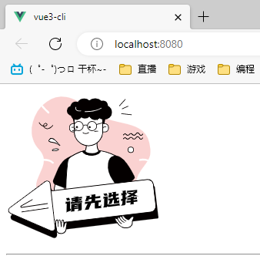

- 可在 <svg></svg> 内使用 width、height 属性修改矢量图尺寸
<template>
<svg width="200px" height="200px" viewBox="0 0 1024 1024" xmlns="http://www.w3.org/2000/svg" id="b52015b4-2459-46df-970a-a6cd264bdde9">
<title>党建1024px尺寸</title>
<rect height="1024" width="1024" class="bd557e99-0b60-410e-9190-ab39419af894"></rect>
<path d="M892.19,468.81a6.4,6.4,0,0,1-2.87-12.48c1.71-.39,30.78-6.8,57.52,3.93,10-19.51,15.95-41.22,13.34-68.57C937.69,155.37,715.46,279.07,512.3,101.94c-102.19-89.1-203.12-67.57-268.64-3.67,12.66,18.83,31.68,36.7,42.36,45.3a6.4,6.4,0,0,1-8,10A270.16,270.16,0,0,1,242.43,118q-4.32-5.28-7.87-10.34c-70.65,77.13-93.35,205-17.69,283.08,21.76,22.47,31.31,44.24,33.46,65.51,25.26-.61,49.85,4.24,64.92,21a6.4,6.4,0,1,1-9.52,8.56c-12.19-13.54-33-17.5-55-16.89C247.4,586.07,45.29,689.44,470,816.65c213.73,64,320.93,33.34,364.64-46,43.41-78.83,18.26-98.79,32.05-169.25,11.26-57.6,49.61-90.25,73.73-129.75C917.6,463.19,892.55,468.73,892.19,468.81Z"
class="a54ce527-3476-4590-b6a3-daf0baba896f"></path>
<path d="M445.95,222.22h36.11a0,0,0,0,1,0,0v55.21a0,0,0,0,1,0,0H445.95A24.41,24.41,0,0,1,421.53,253v-6.38a24.41,24.41,0,0,1,24.41-24.41Z"
class="ec866187-f413-49ef-aca1-b2c926a96c4c"></path>
<path d="M482.06,279.56H445.22a25.85,25.85,0,0,1-25.82-25.82v-7.83a25.85,25.85,0,0,1,25.82-25.82h36.84a2.13,2.13,0,0,1,2.13,2.13v55.21A2.13,2.13,0,0,1,482.06,279.56Zm-36.84-55.21a21.58,21.58,0,0,0-21.55,21.56v7.83a21.58,21.58,0,0,0,21.55,21.55h34.71V224.35Z"
class="e1c3efd2-ec07-48e8-9f5a-049331813ab8"></path>
<path d="M437.16,246.55s17.11-3.73,22.44,7.16" class="ec866187-f413-49ef-aca1-b2c926a96c4c"></path>
<path d="M459.6,255.85a2.12,2.12,0,0,1-1.91-1.2c-4.55-9.28-19.92-6.05-20.07-6a2.13,2.13,0,1,1-.91-4.16c.76-.17,18.81-3.95,24.81,8.3a2.14,2.14,0,0,1-1,2.86A2.09,2.09,0,0,1,459.6,255.85Z"
class="e1c3efd2-ec07-48e8-9f5a-049331813ab8"></path>
<path d="M332.29,593.16S311,678.51,317.59,720.67s51,22.29,51,22.29L395.9,613.49l-67.83-19.67"
class="ec866187-f413-49ef-aca1-b2c926a96c4c"></path>
<path d="M346.64,749.79a33,33,0,0,1-15.85-3.66c-8.26-4.49-13.42-13-15.31-25.13-5.84-37.56,9.77-107.47,13.83-124.6l-1.83-.54a2.13,2.13,0,1,1,1.19-4.09l1.69.49a2.13,2.13,0,0,1,4.05,1.17l62.09,18a2.13,2.13,0,0,1,1.49,2.49L370.64,743.41a2.13,2.13,0,0,1-1.22,1.5A62.14,62.14,0,0,1,346.64,749.79Zm-13.22-152.2c-4,17.19-19.35,86.6-13.73,122.75,1.68,10.8,6.1,18.21,13.12,22,12.38,6.75,29.62.73,33.89-1L393.41,615Z"
class="e1c3efd2-ec07-48e8-9f5a-049331813ab8"></path>
<path d="M439.67,436s-56.4,7.71-93.12,81.48c-13.84,27.81-23.65,58.87-32.77,77.8a22.12,22.12,0,0,0,11.62,30.09l52.89,21.52a22.15,22.15,0,0,0,28.63-11.63l34.64-79.12Z"
class="e1c3efd2-ec07-48e8-9f5a-049331813ab8"></path>
<path d="M644.74,404.62a245.08,245.08,0,0,0-58.61-5.74H555.21c-43.81-.85-87.52,18-126.43,42.89a41.54,41.54,0,0,0-18.87,29.16c-6,41.91-18.12,158.8-12.63,391,0,0,258.89,12.8,361.29-25.6L719.21,587.27,750,448.09c-23.87-17.07-72.12-36-105.3-43.47"
class="ec866187-f413-49ef-aca1-b2c926a96c4c"></path>
<path d="M493.66,866.07c-55,0-95.47-1.93-96.49-2a2.14,2.14,0,0,1-2-2.08c-5.53-234.23,7-351.73,12.66-391.38A43.73,43.73,0,0,1,427.63,440c46.08-29.44,89.08-44,127.63-43.22h30.85a249.59,249.59,0,0,1,59.1,5.78c31.37,7,80.84,25.78,106.07,43.83a2.11,2.11,0,0,1,.84,2.19L721.38,587.33,760.68,836a2.13,2.13,0,0,1-1.36,2.33C697.66,861.48,578.45,866.07,493.66,866.07Zm-94.3-6.15C423.46,861,659,870.3,756.19,835L717.1,587.6a2.1,2.1,0,0,1,0-.79L747.65,449c-25.13-17.49-72.88-35.5-103.37-42.32a245.11,245.11,0,0,0-58-5.69h-31c-38-.76-79.94,13.58-125.28,42.56A39.45,39.45,0,0,0,412,471.23C406.41,510.66,394,627.35,399.36,859.92Z"
class="e1c3efd2-ec07-48e8-9f5a-049331813ab8"></path>
<path d="M850.47,591.22l-74.11,66.25a16.69,16.69,0,0,1-24.53-2.53l-45-60.84c-22.81-30.83-33.63-69.25-28.57-107.26,3.4-25.54,13.95-47.5,39.51-52,64-11.41,117.41,99.55,136.45,136.28A16.7,16.7,0,0,1,850.47,591.22Z"
class="e1c3efd2-ec07-48e8-9f5a-049331813ab8"></path>
<polygon
points="785.54 635.83 841.01 576.09 823.94 537.69 785.54 537.69 759.94 567.56 759.94 593.16 785.54 635.83"
class="e1c3efd2-ec07-48e8-9f5a-049331813ab8"></polygon>
<path d="M438.57,174.74s14.21,37.9,9.48,47.38c0,0,4.73-4.74,14.21,0V189Z"
class="e1c3efd2-ec07-48e8-9f5a-049331813ab8"></path>
<path d="M533.27,359.24s3.15,27.63-7.78,44.71c-5,7.8-1,18.22,7.75,21.32,18.55,6.58,48,11,81.29-6.7a10,10,0,0,0,3.23-15c-7-8.95-15.26-26.54-12.13-58.23Z"
class="ec866187-f413-49ef-aca1-b2c926a96c4c"></path>
<path d="M566.33,433.17a101.24,101.24,0,0,1-33.8-5.89,17,17,0,0,1-10.46-10.56,16,16,0,0,1,1.62-13.92c10.39-16.23,7.5-43.05,7.46-43.32a2.15,2.15,0,0,1,1.72-2.34l72.36-13.93a2.1,2.1,0,0,1,1.84.52,2.16,2.16,0,0,1,.69,1.78c-3,30.64,4.68,47.75,11.68,56.7a12.19,12.19,0,0,1-3.91,18.25C597.71,429.89,581,433.17,566.33,433.17ZM535.57,361c.51,6.76,1.34,29.1-8.29,44.13a11.78,11.78,0,0,0-1.17,10.23,12.78,12.78,0,0,0,7.84,7.93c18.35,6.51,47.06,10.64,79.59-6.58a7.91,7.91,0,0,0,2.54-11.84c-7.26-9.28-15.25-26.63-12.83-56.91Z"
class="e1c3efd2-ec07-48e8-9f5a-049331813ab8"></path>
<path transform="translate(1301.48 499.65) rotate(180)"
d="M642.37,222.22H681a0,0,0,0,1,0,0v55.21a0,0,0,0,1,0,0H646a25.55,25.55,0,0,1-25.55-25.55v-7.77a21.89,21.89,0,0,1,21.89-21.89Z"
class="ec866187-f413-49ef-aca1-b2c926a96c4c"></path>
<path d="M657.31,279.56H620.48a2.13,2.13,0,0,1-2.14-2.13V222.22a2.13,2.13,0,0,1,2.14-2.13h36.83a25.85,25.85,0,0,1,25.83,25.82v7.83A25.85,25.85,0,0,1,657.31,279.56Zm-34.7-4.27h34.7a21.58,21.58,0,0,0,21.56-21.55v-7.83a21.58,21.58,0,0,0-21.56-21.56h-34.7Z"
class="e1c3efd2-ec07-48e8-9f5a-049331813ab8"></path>
<path d="M525.86,130.65h44.46a72.62,72.62,0,0,1,72.62,72.62v70.87A94.85,94.85,0,0,1,548.09,369h0a94.85,94.85,0,0,1-94.85-94.85V203.27A72.62,72.62,0,0,1,525.86,130.65Z"
class="ec866187-f413-49ef-aca1-b2c926a96c4c"></path>
<path d="M548.09,371.12a97.08,97.08,0,0,1-97-97V130.65a2.13,2.13,0,0,1,2.13-2.13h189.7a2.13,2.13,0,0,1,2.13,2.13V274.14A97.09,97.09,0,0,1,548.09,371.12ZM455.37,132.79V274.14a92.72,92.72,0,1,0,185.44,0V132.79Z"
class="e1c3efd2-ec07-48e8-9f5a-049331813ab8"></path>
<path d="M676.45,102.77c.11-.85.21-1.71.25-2.59.72-16.45-12.91-30.41-30.45-31.19a33.66,33.66,0,0,0-12.36,1.77c-9.24-9.8-23.44-16.41-39.63-17.12-16.68-.73-31.8,5-41.86,14.41A47.16,47.16,0,0,0,521,54.43c-18.78-.82-35.36,9.11-43,24a34.49,34.49,0,0,0-13.45-3.38c-17.92-.79-33.35,12.26-37,30.1-13.1,5.23-22.43,16.57-23,30.12-.69,15.6,10.38,29.32,26.26,34.51a39.26,39.26,0,0,0,69.4,10.43,44.06,44.06,0,0,0,23.21,7.88,44.52,44.52,0,0,0,31.35-11.16c7.8,12.32,20.67,20.67,35.6,21.33a43.68,43.68,0,0,0,31.31-11.58,55.76,55.76,0,0,0,27.7,8.73c29.29,1.29,54-19.74,55.2-47C705.39,128.9,693.85,111.52,676.45,102.77Z"
class="e1c3efd2-ec07-48e8-9f5a-049331813ab8"></path>
<path d="M464.17,272.26h-.11L441.53,271a2.13,2.13,0,0,1-2-2.24,2.06,2.06,0,0,1,2.24-2L464.29,268a2.13,2.13,0,0,1-.12,4.26Z"
class="e1c3efd2-ec07-48e8-9f5a-049331813ab8"></path>
<path d="M587.91,275.29a2.13,2.13,0,0,1-.12-4.26l22.52-1.23a2,2,0,0,1,2.25,2,2.13,2.13,0,0,1-2,2.24L588,275.29Z"
class="e1c3efd2-ec07-48e8-9f5a-049331813ab8"></path>
<path d="M482.17,271A32.93,32.93,0,1,1,515.1,238.1,33,33,0,0,1,482.17,271Zm0-61.6a28.67,28.67,0,1,0,28.66,28.67A28.69,28.69,0,0,0,482.17,209.43Z"
class="e1c3efd2-ec07-48e8-9f5a-049331813ab8"></path>
<path d="M571.77,271A32.93,32.93,0,1,1,604.7,238.1,33,33,0,0,1,571.77,271Zm0-61.6a28.67,28.67,0,1,0,28.66,28.67A28.69,28.69,0,0,0,571.77,209.43Z"
class="e1c3efd2-ec07-48e8-9f5a-049331813ab8"></path>
<path d="M540.16,236.89a2.16,2.16,0,0,1-1.42-.54c-9.2-8.25-21.66-.16-22.19.19a2.14,2.14,0,0,1-2.36-3.56c5.39-3.59,18-8.18,27.4.19a2.13,2.13,0,0,1-1.43,3.72Z"
class="e1c3efd2-ec07-48e8-9f5a-049331813ab8"></path>
<path d="M488.08,139.94c-11.06,0-18.9-2.77-23.37-8.27-6.55-8.07-3.16-18.74-3-19.19a2.14,2.14,0,0,1,4.06,1.33c0,.09-2.81,9,2.28,15.19,4.57,5.6,14.47,7.74,28.62,6.16a2.1,2.1,0,0,1,2.35,1.89,2.13,2.13,0,0,1-1.88,2.35A81.76,81.76,0,0,1,488.08,139.94Z"
class="bf745ff3-d487-4892-9840-f9bc03550fe1"></path>
<path d="M535.18,144.42c-6.19,0-9.87-.26-10-.27a2.14,2.14,0,0,1,.32-4.26c.61.05,61.48,4.35,107.71-23.39a2.14,2.14,0,1,1,2.2,3.66C599.35,141.78,554.77,144.42,535.18,144.42Z"
class="bf745ff3-d487-4892-9840-f9bc03550fe1"></path>
<path d="M528.76,290.1c-12.07,0-19.06-6.79-19.16-6.9a2.13,2.13,0,0,1,3-3c.56.55,13.45,12.8,35.3-.32a2.13,2.13,0,1,1,2.19,3.66C541.9,288.44,534.71,290.1,528.76,290.1Z"
class="e1c3efd2-ec07-48e8-9f5a-049331813ab8"></path>
<path d="M464.2,195.4a2.12,2.12,0,0,1-1.77-3.31c.1-.16,10.56-15.52,26.13-10.32a2.13,2.13,0,1,1-1.35,4c-12.52-4.18-21.15,8.5-21.23,8.63A2.14,2.14,0,0,1,464.2,195.4Z"
class="e1c3efd2-ec07-48e8-9f5a-049331813ab8"></path>
<path d="M607.33,198.49a2.13,2.13,0,0,1-2.07-1.61c0-.07-1.86-7-7.41-9.58-3.56-1.63-8-1.13-13.26,1.49a2.13,2.13,0,1,1-1.9-3.82c6.46-3.23,12.18-3.74,17-1.54,7.41,3.41,9.65,12,9.74,12.41a2.13,2.13,0,0,1-1.55,2.58A1.91,1.91,0,0,1,607.33,198.49Z"
class="e1c3efd2-ec07-48e8-9f5a-049331813ab8"></path>
<path d="M274.39,258a27.07,27.07,0,0,1-12.7-3.16c-8.21-4.25-12.65-9.51-14.57-14.57-20.07-3.76-29.48-24-29.58-24.28a2.13,2.13,0,0,1,3.88-1.76c.39.85,8.12,17.39,24.62,21.46a15.93,15.93,0,0,1,.45-5.7c2-7.56,9.28-12.59,17.7-12.19,4.94.22,9.46,5.06,9.67,10.35.09,2.45-.75,10.59-15.54,12.42a36.76,36.76,0,0,1-6.23.26c1.95,3.53,5.59,7.13,11.56,10.23,22,11.41,44.91-18.36,45.14-18.67a2.13,2.13,0,0,1,3.4,2.58C311.34,236.08,294.47,258,274.39,258Zm-23.93-21.55a33.63,33.63,0,0,0,7.34-.12c7.66-.95,12-3.87,11.79-8-.12-3.09-2.84-6.13-5.6-6.26-6.42-.32-11.88,3.43-13.38,9A11.93,11.93,0,0,0,250.46,236.44Z"
class="a635c0bf-c78a-49dd-bca9-cad7ca5aedca"></path>
<circle r="18.44" cy="395.68" cx="829.65" class="ec866187-f413-49ef-aca1-b2c926a96c4c"></circle>
<path d="M829.65,416.26a20.58,20.58,0,1,1,20.57-20.58A20.6,20.6,0,0,1,829.65,416.26Zm0-36.89A16.31,16.31,0,1,0,846,395.68,16.33,16.33,0,0,0,829.65,379.37Z"
class="e1c3efd2-ec07-48e8-9f5a-049331813ab8"></path>
<circle r="6.23" cy="245.25" cx="470.74" class="e1c3efd2-ec07-48e8-9f5a-049331813ab8"></circle>
<circle r="6.23" cy="245.25" cx="556.08" class="e1c3efd2-ec07-48e8-9f5a-049331813ab8"></circle>
<path d="M357.84,367.36s-46.93-67.49-68.26-41.89c-14,16.79,6.81,18.61,17.05,20a113.51,113.51,0,0,1,18.15,4C334.86,352.7,348.34,358.29,357.84,367.36Z"
class="ec866187-f413-49ef-aca1-b2c926a96c4c"></path>
<path d="M357.84,369.49a2.13,2.13,0,0,1-1.47-.59c-9.3-8.88-22.66-14.33-32.23-17.33a109.87,109.87,0,0,0-17.8-3.94l-1.61-.22c-7.93-1.07-18.79-2.54-21.42-9.3-1.51-3.88,0-8.46,4.63-14a17,17,0,0,1,14.35-6.55c24,1.05,55.95,46.64,57.3,48.58a2.13,2.13,0,0,1-1.75,3.35Zm-56.4-47.68a12.76,12.76,0,0,0-10.23,5c-2.39,2.88-5,6.9-3.92,9.72,1.71,4.42,11.91,5.8,18,6.63l1.63.22a113.68,113.68,0,0,1,18.49,4.09,108.49,108.49,0,0,1,21.7,9.34c-11.09-13.64-30.3-34.37-45-35Z"
class="e1c3efd2-ec07-48e8-9f5a-049331813ab8"></path>
<ellipse transform="translate(-50.29 47.73) rotate(-7.73)" ry="6.4" rx="21.33" cy="395.87" cx="327.98"
class="ec866187-f413-49ef-aca1-b2c926a96c4c"></ellipse>
<path d="M320.05,405a44.74,44.74,0,0,1-6.74-.47c-5.32-.84-8.21-2.68-8.58-5.47h0c-.79-5.81,10.9-10.09,22.1-11.61a57.37,57.37,0,0,1,15.82-.17c5.32.84,8.21,2.68,8.58,5.47.79,5.81-10.9,10.09-22.1,11.61A67.75,67.75,0,0,1,320.05,405ZM309,398.46c.59,1.13,7.33,3.3,19.59,1.64s18.29-5.63,18.45-6.84c-.47-1.07-7.21-3.3-19.59-1.61S309.22,397.2,309,398.46Z"
class="e1c3efd2-ec07-48e8-9f5a-049331813ab8"></path>
<path d="M664.7,179.29s-12.8,34.14-8.53,42.67c0,0-4.27-4.27-12.8,0V192.09Z"
class="e1c3efd2-ec07-48e8-9f5a-049331813ab8"></path>
<path d="M897.37,302.36c-4.78,0-9.17-3.36-13.07-10-3.09-5.24-6.25-8-9.14-8.08h-.06c-3.64,0-6.74,4.3-7.9,6.16a29.27,29.27,0,0,1-6.45,7.6c-7.45,5.85-15.35,4.85-21.69-2.76-3.14-3.77-6.14-5.68-8.91-5.68s-4.94,1.91-6.27,3.52c-3,3.58-5.89,5.9-8.89,7.09-4.29,1.7-10.74,2.36-17-4.22-2.5-2.61-5-3.84-7.56-3.58-4.92.44-8.62,6-8.66,6a2.13,2.13,0,0,1-3.57-2.34c.19-.3,4.85-7.3,11.81-7.94,3.9-.36,7.62,1.28,11.06,4.88,3.74,3.91,7.92,5,12.39,3.2,2.32-.92,4.68-2.83,7.19-5.85,1.92-2.31,5.13-5.06,9.54-5.06h0c4.1,0,8.2,2.43,12.19,7.22,4.92,5.91,10.08,6.61,15.78,2.13a25,25,0,0,0,5.47-6.51c1.93-3.08,6.15-8.14,11.64-8.15,4.52.06,8.81,3.49,12.74,10.18,3.08,5.23,6.24,7.89,9.41,7.89h.06c4.56,0,8.75-5.74,10-7.93a2.13,2.13,0,0,1,3.73,2.07c-.23.42-5.68,10-13.65,10.12Z"
class="e1c3efd2-ec07-48e8-9f5a-049331813ab8"></path>
<path d="M897.37,327.67c-4.78,0-9.17-3.36-13.07-10-3.09-5.25-6.25-8-9.14-8.08h-.06c-3.64,0-6.74,4.3-7.9,6.15a29.27,29.27,0,0,1-6.45,7.6c-7.45,5.86-15.35,4.85-21.69-2.76-3.14-3.77-6.14-5.68-8.91-5.68s-4.94,1.92-6.27,3.52c-3,3.58-5.89,5.9-8.89,7.09-4.29,1.7-10.74,2.37-17-4.22-2.5-2.6-5-3.82-7.56-3.58-4.92.44-8.62,6-8.66,6a2.13,2.13,0,0,1-3.57-2.33c.19-.3,4.85-7.3,11.81-7.95,3.9-.36,7.62,1.29,11.06,4.88,3.74,3.91,7.92,5,12.39,3.21,2.32-.92,4.68-2.84,7.19-5.86,1.92-2.3,5.13-5.05,9.54-5.05h0c4.1,0,8.2,2.42,12.19,7.21,4.92,5.91,10.08,6.62,15.78,2.14a25.19,25.19,0,0,0,5.47-6.52c1.93-3.07,6.15-8.25,11.64-8.15,4.52.07,8.81,3.49,12.74,10.19,3.08,5.23,6.24,7.88,9.41,7.88h.06c4.56,0,8.75-5.74,10-7.93a2.14,2.14,0,0,1,3.73,2.08c-.23.41-5.68,10-13.65,10.12Z"
class="e1c3efd2-ec07-48e8-9f5a-049331813ab8"></path>
<path d="M643.37,254a2.27,2.27,0,0,1-.62-.09,2.14,2.14,0,0,1-1.42-2.67c0-.13,4.34-13.44,23.83-9.2a2.13,2.13,0,1,1-.91,4.17c-15.68-3.44-18.81,6.18-18.84,6.28A2.13,2.13,0,0,1,643.37,254Z"
class="e1c3efd2-ec07-48e8-9f5a-049331813ab8"></path>
<path d="M572.84,418.61c-26.78,1.08-41.24-6.35-48.94-17.45-4.26,0-17.2,1.18-17.06,4.27.68,15.16,33.43,31.08,66,29.78s58.4-17.31,57.72-32.48c-.09-2-6.08-2.06-9.9-2.92a5.12,5.12,0,0,0-5.17,1.78C608,411.08,596.26,417.68,572.84,418.61Z"
class="e1c3efd2-ec07-48e8-9f5a-049331813ab8"></path>
<rect transform="translate(-88.61 79.51) rotate(-6.78)" rx="8.78" height="217.6" width="755.2" y="678.39"
x="248.8" class="e1c3efd2-ec07-48e8-9f5a-049331813ab8"></rect>
<path d="M273.3,652.83a20.79,20.79,0,0,1,33,14.36l16.54,145.56L339.39,958.3a20.78,20.78,0,0,1-28.94,21.41L176.13,921.26,41.8,862.81A20.78,20.78,0,0,1,37.74,827l117.78-87.11Z"
class="e1c3efd2-ec07-48e8-9f5a-049331813ab8"></path>
<path transform="translate(-83.26 77.63) rotate(-6.78)"
d="M244.37,632.3H982a8.78,8.78,0,0,1,8.78,8.78V807.91a42,42,0,0,1-42,42H244.37a8.78,8.78,0,0,1-8.78-8.78v-200a8.78,8.78,0,0,1,8.78-8.78Z"
class="ec866187-f413-49ef-aca1-b2c926a96c4c"></path>
<path d="M283.84,891.71a39.66,39.66,0,0,1-39.3-34.93L227.69,715.14a39.59,39.59,0,0,1,34.65-44l675.48-80.36a39.67,39.67,0,0,1,44,34.66l16.85,141.64a39.61,39.61,0,0,1-34.66,44L288.55,891.43A39.53,39.53,0,0,1,283.84,891.71Zm658.68-297a35.29,35.29,0,0,0-4.2.25L262.84,675.36a35.35,35.35,0,0,0-30.92,39.27l16.85,141.64A35.37,35.37,0,0,0,288,887.2l675.48-80.37a35.34,35.34,0,0,0,30.93-39.27L977.6,625.92A35.41,35.41,0,0,0,942.52,594.75Z"
class="e1c3efd2-ec07-48e8-9f5a-049331813ab8"></path>
<path d="M260.08,606.74a20.79,20.79,0,0,1,33,14.36l16.55,145.56,16.54,145.55a20.78,20.78,0,0,1-28.94,21.41L162.91,875.17,28.58,816.72A20.79,20.79,0,0,1,24.52,781L142.3,693.84Z"
class="ec866187-f413-49ef-aca1-b2c926a96c4c"></path>
<path d="M305.59,937.51a22.93,22.93,0,0,1-9.2-1.94L27.74,818.67a22.92,22.92,0,0,1-4.49-39.44L258.82,605a22.91,22.91,0,0,1,36.39,15.84L328.3,912a23,23,0,0,1-22.71,25.54ZM272.4,604.77a18.56,18.56,0,0,0-11,3.68L25.79,782.66a18.65,18.65,0,0,0,3.65,32.1l268.65,116.9a18.65,18.65,0,0,0,26-19.21L291,621.35a18.75,18.75,0,0,0-18.57-16.58Z"
class="e1c3efd2-ec07-48e8-9f5a-049331813ab8"></path>
<path d="M845.06,839.08c8.53,4.27,5.33,7.21-5.42,31.41,0,.07,0,4.27,0,12.8,0,14.41-11.42,24-25.19,28.2l-.41.13c-42.67,12.8-67.12-21.34-67.12-21.34S725.59,869,725.59,856.15s17.07,0,17.07,0c-4.27-21.33,12.8-8.53,12.8-8.53-4.27-21.34,17.06-4.27,17.06-4.27-4.26-17.07,8.54-12.8,17.07,0,7,10.46,25.6,17.07,25.6,17.07S834.26,833.69,845.06,839.08Z"
class="ec866187-f413-49ef-aca1-b2c926a96c4c"></path>
<path d="M795.37,916.6c-31.79,0-50-24.78-50.18-25.08-.67-.62-21.73-21.84-21.73-35.37,0-4.47,1.89-6.36,3.48-7.15,3.7-1.85,9.16.54,12.95,2.77-.3-4.64.73-7.66,3.12-9.17,2.93-1.84,6.83-.62,9.77.86-.16-3.91.86-6.49,3.07-7.83,3.77-2.3,9.66.47,13.74,3-.33-5.23,1.59-7.37,3.52-8.22,5.3-2.34,13.19,4.13,18.25,11.73,5.4,8.09,18.64,13.9,23.07,15.67,4.45-6,20.58-26.16,31.58-20.67,9.1,4.55,7,9.22-.12,24.69-1.21,2.64-2.59,5.66-4.13,9.11v12.32c0,13.83-10,25.14-26.7,30.24l-.41.13A67.13,67.13,0,0,1,795.37,916.6Zm-65.33-64a2.72,2.72,0,0,0-1.19.23c-.93.47-1.13,2.07-1.13,3.34,0,9.77,14.95,26.86,20.71,32.62,1.19,1.61,24.33,33,65,20.8l.43-.13c14.79-4.51,23.65-14.29,23.65-26.15v-8.51c0-4.69,0-4.69.19-5.14,1.62-3.65,3.06-6.81,4.32-9.56,7.5-16.38,7.2-16.54,2.09-19.09h0c-6.65-3.34-20.21,10.91-27.17,20.67a2.14,2.14,0,0,1-2.45.77c-.79-.28-19.38-7-26.67-17.9-5.07-7.62-11-11.08-13-10.19-.8.35-1.74,2.53-.25,8.49a2.14,2.14,0,0,1-3.4,2.19c-4.08-3.27-10.93-7.1-13.13-5.75-.44.27-1.77,1.63-.51,7.93a2.13,2.13,0,0,1-3.37,2.12c-2.65-2-7.21-4.16-8.89-3.11-.51.32-2,2-.54,9.52a2.14,2.14,0,0,1-3.37,2.13C738.23,855.5,733,852.58,730,852.58Z"
class="e1c3efd2-ec07-48e8-9f5a-049331813ab8"></path>
<path d="M772.52,843.35s4.27,17.07,25.6,25.6" class="ec866187-f413-49ef-aca1-b2c926a96c4c"></path>
<path d="M798.12,871.08a2.21,2.21,0,0,1-.79-.15c-22.09-8.84-26.69-26.32-26.88-27.06a2.15,2.15,0,0,1,1.55-2.59,2.11,2.11,0,0,1,2.59,1.55c.17.65,4.35,16.15,24.32,24.14a2.13,2.13,0,0,1-.79,4.11Z"
class="e1c3efd2-ec07-48e8-9f5a-049331813ab8"></path>
<path d="M755.46,847.62S764,869,785.32,877.48" class="ec866187-f413-49ef-aca1-b2c926a96c4c"></path>
<path d="M785.32,879.62a2,2,0,0,1-.79-.16c-21.93-8.77-30.69-30.15-31-31.05a2.13,2.13,0,0,1,4-1.59c.08.21,8.48,20.6,28.67,28.68a2.14,2.14,0,0,1-.79,4.12Z"
class="e1c3efd2-ec07-48e8-9f5a-049331813ab8"></path>
<path d="M742.66,856.15s8.53,21.33,25.6,29.87" class="ec866187-f413-49ef-aca1-b2c926a96c4c"></path>
<path d="M768.26,888.15a2.09,2.09,0,0,1-1-.23c-17.59-8.79-26.26-30.08-26.62-31a2.13,2.13,0,1,1,4-1.58c.08.2,8.45,20.69,24.57,28.75a2.13,2.13,0,0,1-1,4Z"
class="e1c3efd2-ec07-48e8-9f5a-049331813ab8"></path>
<path d="M337.39,936.38s-18.13-75.41,0-75.41c10.05,0,10.05,45.25,10.05,45.25S342.42,856,357.5,861c4.77,1.59,10.05,45.25,10.05,45.25S366.37,861,377.61,861c10.05,0,5,45.25,5,45.25s12.16-38.11,20.11-30.16c5,5-2.7,29.35-2.8,35-.31,17.31-2.23,35.34-27.36,40.37C362.51,953.47,342.42,951.46,337.39,936.38Z"
class="ec866187-f413-49ef-aca1-b2c926a96c4c"></path>
<path d="M365.45,954.23c-10.84,0-25.6-3.73-30.09-17.18a1.54,1.54,0,0,0-.05-.17c-1.51-6.29-14.47-61.84-4.16-74.92a7.74,7.74,0,0,1,6.24-3.12c1.71,0,5.72,1.22,8.67,11.54,1-4.61,2.59-8.39,5-10.32a7.23,7.23,0,0,1,7.1-1.11c3.14,1,5.89,11.21,8.12,23.71.94-8.95,2.82-17.86,6.5-21.64,2.65-2.71,6.52-3,9-.21,4.23,4.72,4.58,19.13,4.11,30.57,3.57-8.32,8.43-17.22,13.26-18.4a5.29,5.29,0,0,1,5.11,1.57c4,4,2.19,14.57-.64,27.93a68,68,0,0,0-1.54,8.65c-.32,18.59-2.83,37.17-29.08,42.42A39.41,39.41,0,0,1,365.45,954.23Zm-26-18.44c4.78,14.1,24.46,15.22,32.72,13.58,23.15-4.63,25.34-20.76,25.64-38.31a65.75,65.75,0,0,1,1.64-9.46c1.57-7.45,4.5-21.33,1.79-24-.56-.55-.88-.49-1.09-.43-4.48,1.09-11.75,18-15.48,29.74a2.13,2.13,0,0,1-4.15-.89c1.54-13.82,2.37-37.53-1.92-42.33a1.25,1.25,0,0,0-1-.54,2.37,2.37,0,0,0-1.77.89c-5.8,6-6.41,32.45-6.15,42.16a2.13,2.13,0,0,1-4.25.31c-2.33-19.24-6.39-41.39-8.89-43.61a2.87,2.87,0,0,0-2.82.53c-3.43,2.74-4.75,12.6-4.94,23.07.5,5.45.79,12,.79,19.76a2.14,2.14,0,0,1-4.26.21,187.33,187.33,0,0,1-.84-18.84c-1.24-13.63-3.79-24.48-7.09-24.48a3.49,3.49,0,0,0-2.89,1.49C326.86,874.29,335.46,919.18,339.44,935.79Z"
class="e1c3efd2-ec07-48e8-9f5a-049331813ab8"></path>
<path d="M402.17,810.73l1-57.07-7.15.87.28-13.19,29.52-3.6L424.91,788l6.26-2.64-.32,13.87Zm18-96,5.3,16-20.78,2.53-5.3-16Zm37.38,12.51v-3.35l-23.69,2.88.12-10.09,23.82-2.9,0-.94-5.36-4.32,28.46-3.47-.22,5.94,23.95-2.92-.11,10.09-24,2.92-.12,3.37,19.85-2.42-.23,10.24-19.72,2.4-.13,3.38,25.94-3.17-.22,10.24-75.58,9.21.23-10.24,26.6-3.24.13-3.37-20.91,2.55.23-10.24Zm18.34,74.47,5.07-8,.05-7.26-26.33,3.21-.23,14.67L432.74,807l1-50.49L503.46,748l-.84,41.6a13.37,13.37,0,0,1-1.61,6.58,6.45,6.45,0,0,1-5.13,3.11Zm-21-21.09,26.34-3.21.06-3.9L455,776.77Zm.17-12.92,26.34-3.21.1-3.63-26.34,3.2Z"></path>
<path d="M535.82,707.15l-3.77-3.44,26.34-3.21-3.28,10.61,13.1-1.6.25-10.1-5-4.5,30.18-3.67-.3,15.21,32.69-4-.19,12.78-32.82,4-.28,15.35L630.61,730l-.32,12.8-15.08,1.84-.4,24.36,12.58-1.53,5.07-5.72-.36,20.19L598.35,786a7.82,7.82,0,0,1-6.39-1.77,7.27,7.27,0,0,1-2.36-6.16l.46-30.42-23.43,2.86L549.12,792,524,795.09l17.52-41.49-16.81,2,.31-12.8,42.62-5.19L568,722.3,551,724.38,547.68,735l-21.31,2.6Z"></path>
<path d="M646.4,779.1l5.22-13.39.84-46.05-5,.62.19-12.78,27.66-3.37-.89,53.3,18.79,3.21,61.55-7.49-.19,12.78-70.42,8.58-13.43-2.26-1.65,4.1Zm21.8-94.53L675.46,699l-20.11,2.45L648.08,687Zm35.21-4.29L701,693.34l9.67-1.18.23-10.23-5-4.5L731,674.37l-.28,15.34,17.61-2.14L748.13,699l-17.6,2.15-.17,12.91,20.11-2.45-.21,11.45-12.57,1.53-.24,10.23,10.06-1.22,5.21-5.74-.46,20.47-35.2,4.29.5-25.58-7.67.93L702,754.47l-20.11,2.45,7.92-26.49-9.93,1.22.22-11.45,30.18-3.67.17-12.92L698.89,705l-1.08,6.58-17.6,2.14L685,687,680.77,683Z"></path>
<path d="M774.31,719.87l.44-22.89-8.61,1,.32-12.8,8.61-1.05.22-11.45-3.65-3.45,24.35-3-.28,15.34,6.36-.77-.32,12.8-6.22.76-.34,17.1,6.28-2.51-.16,14.12-6.41,2.53-.54,28.67a10.33,10.33,0,0,1-2.74,6.71,10,10,0,0,1-6.38,3.27l-20.39,2.48,8.88-13.17.41-19.79-8.73,3.35.31-14ZM827.89,733l.05-6.18-21.84,2.66.3-11.86,21.71-2.65.16-5.25,21.18-2.58-.16,5.26L871,709.7l-.3,11.86-21.57,2.63-.06,6.18,23.43-2.85-.28,12-23.43,2.85-.18,14-21.17,2.58.17-14-26.07,3.18.28-12Zm44.28-73.09,0,1.75-.37,16.84-19.51,13,23.9,10.93-25.54,3.11-11.29-5.61-15.67,10.37-19.06,2.33.17-5.26L826,693.16l-20.75-10.5L827.47,680l10.69,5L854.8,673.8l-49.5,6,.3-11.86Z"></path>
<path d="M102.56,780.5a7.51,7.51,0,0,1-3.6-14l72.91-41.21A2.13,2.13,0,1,1,174,729l-72.91,41.21A3.09,3.09,0,0,0,99.6,774a3.06,3.06,0,0,0,3.54,2.15L275,750.59a2.16,2.16,0,0,1,2.42,1.8,2.12,2.12,0,0,1-1.79,2.42l-171.88,25.6A8.18,8.18,0,0,1,102.56,780.5Z"
class="e1c3efd2-ec07-48e8-9f5a-049331813ab8"></path>
<path d="M104.65,810.3a2.13,2.13,0,0,1-.3-4.24l174.93-25.6a2.13,2.13,0,1,1,.62,4.22L105,810.28A1.56,1.56,0,0,1,104.65,810.3Z"
class="e1c3efd2-ec07-48e8-9f5a-049331813ab8"></path>
<line y2="162.85" x2="833.46" y1="155.86" x1="768.85" class="a226ff1a-3cb1-4ecf-84f6-4ccc6cc0a18d"></line>
<path d="M833.47,165h-.23l-64.62-7a2.14,2.14,0,0,1-1.89-2.35,2.18,2.18,0,0,1,2.35-1.89l64.61,7a2.13,2.13,0,0,1-.22,4.25Z"
class="e1c3efd2-ec07-48e8-9f5a-049331813ab8"></path>
<line y2="123.55" x2="772.35" y1="106.37" x1="811.4" class="a226ff1a-3cb1-4ecf-84f6-4ccc6cc0a18d"></line>
<path d="M772.35,125.69a2.13,2.13,0,0,1-.86-4.09l39-17.19a2.14,2.14,0,0,1,1.72,3.91l-39,17.19A2.18,2.18,0,0,1,772.35,125.69Z"
class="e1c3efd2-ec07-48e8-9f5a-049331813ab8"></path>
<line y2="103.56" x2="754.22" y1="61.5" x1="792.58" class="a226ff1a-3cb1-4ecf-84f6-4ccc6cc0a18d"></line>
<path d="M754.22,105.7a2.14,2.14,0,0,1-1.57-3.58L791,60.07a2.13,2.13,0,0,1,3.15,2.87L755.8,105A2.14,2.14,0,0,1,754.22,105.7Z"
class="e1c3efd2-ec07-48e8-9f5a-049331813ab8"></path>
<path d="M600.62,230a2.13,2.13,0,0,1-.56-4.19L647,213.05a2.13,2.13,0,1,1,1.13,4.11L601.19,230A2.24,2.24,0,0,1,600.62,230Z"
class="e1c3efd2-ec07-48e8-9f5a-049331813ab8"></path>
</svg>
</template>
<script>
export default {
// eslint-disable-next-line vue/multi-word-component-names
name: 'svg1'
}
</script>
<style>
.bd557e99-0b60-410e-9190-ab39419af894 {
fill: none;
}
.a54ce527-3476-4590-b6a3-daf0baba896f {
fill: #e61f19;
opacity: 0.2;
}
.ec866187-f413-49ef-aca1-b2c926a96c4c {
fill: #fff;
}
.e1c3efd2-ec07-48e8-9f5a-049331813ab8 {
fill: #040000;
}
.bf745ff3-d487-4892-9840-f9bc03550fe1 {
fill: #fffdfd;
}
.a635c0bf-c78a-49dd-bca9-cad7ca5aedca {
fill: #231815;
}
.a226ff1a-3cb1-4ecf-84f6-4ccc6cc0a18d {
fill: #060001;
}
</style>
- 1
- 1
- 1
- 1

②、使用 SVG 文件
- 安装依赖：npm install svg-sprite-loader -D
- 创建目录：src/icons/svg ，将下载的 svg 文件放入其中
- 修改文件 vue.config.js
const {defineConfig} = require('@vue/cli-service')
const path = require('path')
function resolve(dir) {
return path.join(__dirname, '.', dir)
}
module.exports = defineConfig({
transpileDependencies: true,
// 关闭语法检查
lintOnSave: false,
chainWebpack: config => {
// 重点：删除默认配置中处理 svg
config.module.rules.delete("svg");
config.module
.rule('svg-sprite-loader')
.test(/\.svg$/)
.include
// 处理 svg 目录，svg 文件存放的目录
.add(resolve('src/icons/svg'))
.end()
.use('svg-sprite-loader')
.loader('svg-sprite-loader')
.options({
symbolId: 'icon-[name]'
})
},
})
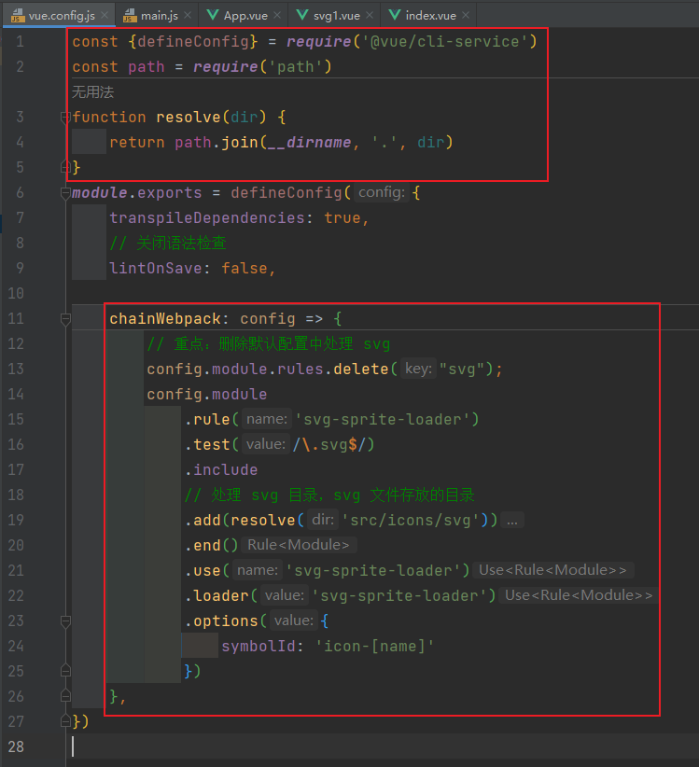
- 修改文件 main.js
// 引入的不再是 Vue 构造函数了，而是一个名为 createApp 的工厂函数
import { createApp } from 'vue'
// 引入 app 组件，他是所有组件的父组件
import App from './App.vue'
// 导入 SvgIcon 组件
import SvgIcon from '@/components/SvgIcon/baseSvgIcon.vue'
const req = require.context('@/icons/svg', false, /\.svg$/)
req.keys().map(req)
// 创建应用实例对象：app(类似于之前 Vue2 中的 vm，但 app 比 vm 更“轻”)
createApp(App).component('svg-icon', SvgIcon).mount('#app')
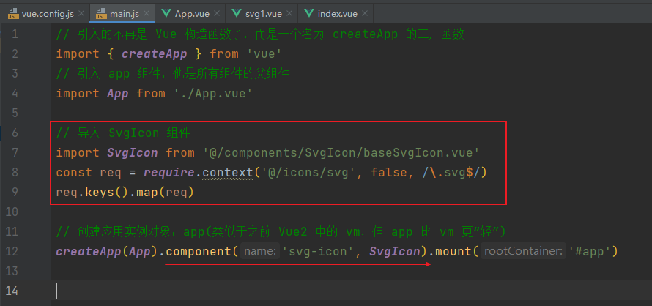
- 在目录 components 中创建目录 SvgIcon ，在其中创建组件 baseSvgIcon.vue
<template>
<!-- 只需要给一个 dom 存放 svg 即可 -->
<svg :class="className" aria-hidden="true">
<!-- 这边是做一个联动，根据传入的 iconName 来展示相关的 svg -->
<use :xlink:href="iconName"></use>
</svg>
</template>
<script>
import { computed } from "@vue/reactivity";
export default {
name: "baseSvgIcon",
// 因为是被调用，所以要传入 props
props: {
// 调用时传入的要使用的 svg 文件
name: { type: String },
// 调用时传入的要使用的 样式
class: { type: String },
},
setup(props) {
// 对传入的 name 进行处理，返回要使用的 svg 文件名
const iconName = computed(() => {
return props.name ? `#icon-${props.name}` : "#icon-趣味插画缺省页";
});
// 对传入的 class 进行处理，返回要使用的 样式名
const className = computed(() => {
return props.class ? `svg-icon${props.class}` : "svg-icon";
});
return { iconName, className };
},
};
</script>
<style scoped>
/* 默认样式 */
.svg-icon {
width: 200px;
height: 200px;
}
</style>
- 在 App 组件中引入 SvgIcon 组件，传入适当的参数即可使用
<template>
<!-- 引入 svg1 组件 -->
<svg1 /><hr>
<!-- 引入 SvgIcon 组件，传递组件名 -->
<SvgIcon name="请先选择" />
<!-- 引入 SvgIcon 组件，传递组件名和样式名 -->
<SvgIcon name="无网络" class="big" />
<hr>
<!-- 引入 SvgIcon 组件，不传递组件名和样式名，使用默认 svg 和 样式 -->
<SvgIcon />
</template>
<script>
import svg1 from './components/svg1.vue'
import SvgIcon from '@/components/SvgIcon/baseSvgIcon.vue'
export default {
name: 'App',
components: { svg1, SvgIcon }
}
</script>
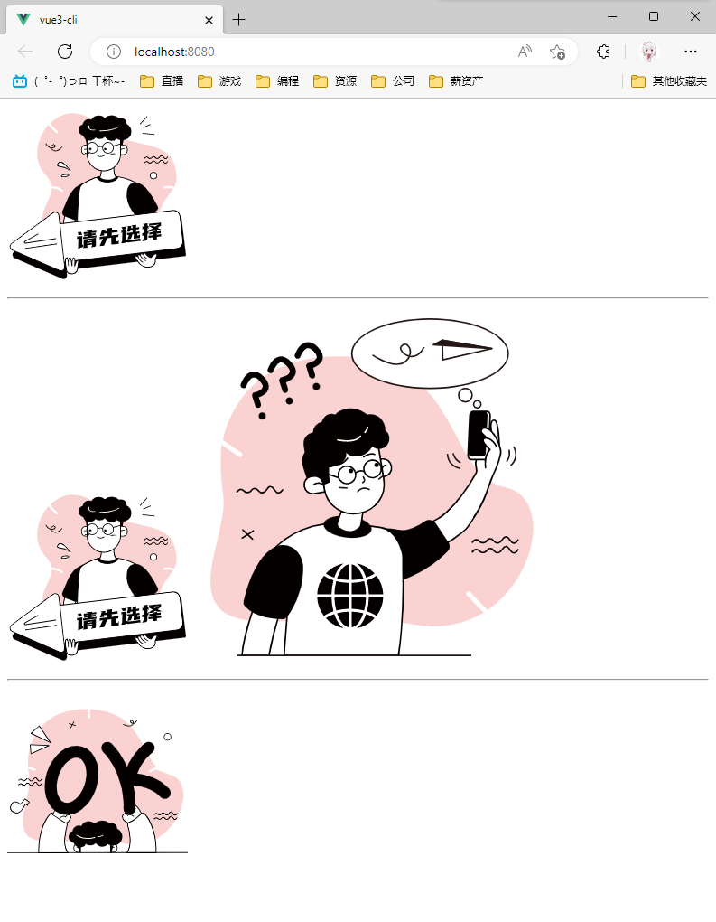

2、使用 axios
- 安装 axios ：npm i axios
- 修改 main.js 文件，引入并使用 provide 派发 axios
// 引入的不再是 Vue 构造函数了，而是一个名为 createApp 的工厂函数
import { createApp } from 'vue'
// 引入 app 组件，他是所有组件的父组件
import App from './App.vue'
// 引入 axios
import axios from 'axios'
// 创建应用实例对象并挂载；使用 provide 派发 axios
createApp(App).provide("$axios", axios).mount('#app')
- 修改（或创建） vue.config.js 文件，配置代理服务器
const {defineConfig} = require('@vue/cli-service')
const path = require('path')
function resolve(dir) {
return path.join(__dirname, '.', dir)
}
module.exports = defineConfig({
transpileDependencies: true,
// 配置代理服务器
devServer: {
proxy: {
// /Boot1：请求前缀
'/Boot1': {
// 需要代理到的服务器
target: 'http://43.138.106.181:9000',
// 正则匹配，将请求路径中的 /Boot1 替换为空；若不加则路径是：http://localhost:8080/Boot1/Test/get
pathRewrite: { '^/Boot1' : '' },
// 用于支持 websocket
ws: true,
// 是否将请求伪装为服务器端口（默认为 true）
changeOrigin: true
},
}
}
})
- 在组件中使用 inject 接受 provide 派发的 axios，然后即可使用 axios 发送请求
<template>
<button @click="getData">请求</button>
<ul>
<li v-for="person in persons" :key="person.id">ID：{{person.id}}，NAME：{{person.name}}</li>
</ul>
</template>
<script>
// 引入 vue 函数
import { ref, inject } from 'vue'
export default {
name: 'HelloWorld',
setup(){
/**
* 基本类型要使用 ref，若是使用 reactive，必须为对象
* 数组若是使用 reactive，arr = nwArr 会使其失去响应式，必须要进行额外的梳理，比如改为使用 push
*/
let persons = ref([])
// 使用 inject 接受 provide 派发的 axios
const $axios = inject("$axios");
const getData = () => {
$axios.get('/Boot1/Test/get').then((data)=>{
console.log("成功", data.data.data)
persons.value = data.data.data
}).catch((data)=>{
console.log("失败", data)
})
}
// 返回一个对象，则对象中的属性、方法，在模板中均可以直接使用
return { persons, getData }
}
}
</script>
- 结果
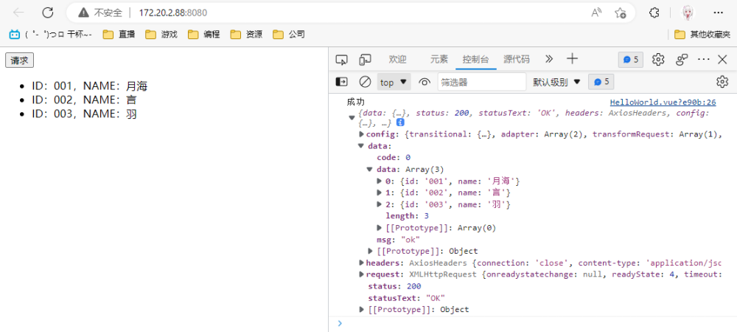

3、vue3 vite 使用 pinia
https://pinia.vuejs.org/zh/introduction.html
Vuex 最新版 = Vuex 5
- 安装：npm install pinia
- 在 main.js 中引入并挂载
import { createApp } from 'vue'
import App from './App.vue'
// 引入 Pinia
import {createPinia} from 'pinia'
createApp(App).use(createPinia()).mount('#app');
- 在 src 文件下创建一个 store 文件夹，并添加 index.js
// 引入 Pinia
import { defineStore } from 'pinia'
/**
* 1. 定义容器、导出容器
* 参数1：容器的ID，必须是唯一的，后面Pinia会把所有的容器挂载到根容器
* 参数2：一些选项对象，也就是state、getter和action
* 返回值：一个函数，调用即可得到容器实例
*/
export const useCounterStore = defineStore('counter', {
/**
* 类似于 Vue2 组件中的 data，用于存储全局状态数据，但有两个要求
* 1. 必须是函数，目的是为了在服务端渲染的时候避免交叉请求导致的数据状态污染
* 2. 必须是箭头函数，这样是为了更好的 TS 类型推导
*/
state: () => {
return {
count: 0
}
},
actions: {},
})
/**
* 2. 使用容器中的 state
* 3. 通过 getter 修改 state
* 4. 使用容器中的 action 同步和异步请求
*/
- 在组件中使用
<template>
111
</template>
<script setup>
import { useCounterStore } from "../store/index.js";
const pinia = useCounterStore();
console.log(pinia.count)
</script>

4、vue3 vite 使用 路由

①、使用
- 安装路由：npm install vue-router@4
- 在 src 目录下新建目录叫 router，新建一个 js 文件叫 index.js，文件内容如下：
// 引入 路由 vue-router
import {createRouter, createWebHistory} from 'vue-router'
// 导入路由页面的配置
import routes from './routes'
// 路由参数配置，默认暴露
export default createRouter({
// 使用hash(createWebHashHistory)模式，(createWebHistory是HTML5历史模式，支持SEO)
history: createWebHistory(),
routes: routes,
})
- 接着新建一个 js 文件叫 routes.js，内容如下(可以自己继续添加其他页面)：
// 路径配置
export default [
{
path: '/PanoramaOfTheScene',
name: 'PanoramaOfTheScene',
component: () => import('../pages/PanoramaOfTheScene.vue')
}
]
- 在 main.js 中使用路由
import { createApp } from 'vue'
import App from './App.vue'
// 引入 路由 router
import router from './router'
createApp(App).use(router)
.mount('#app');
- 使用

②、路由嵌套
- routes.js 中，添加children 属性，在其中添加子路由
// 路径配置
export default [
{
// 登录页
path: '/',
name: 'Login',
component: () => import('../components/Login.vue')
},{
// 主页
path: '/Home',
name: 'Home',
props: true,
component: () => import('../components/Home.vue'),
children: [
{
// 次级目录选项
path: 'Titles',
name: 'Titles',
props: true,
component: () => import('../pages/Home/Titles.vue')
},{
// 侧边栏
path: 'Sider',
name: 'Sider',
props: true,
component: () => import('../pages/Home/Sider.vue'),
children: [
{
// 现场全景
path: 'PanoramaOfTheScene',
name: 'PanoramaOfTheScene',
props: true,
component: () => import('../pages/PanoramaOfTheScene/PanoramaOfTheScene.vue')
},{
// 火灾详情
path: 'FireDetails',
name: 'FireDetails',
component: () => import('../pages/FireDetails/FireDetails.vue')
},{
// 专家连线
path: 'ExpertConnection',
name: 'ExpertConnection',
component: () => import('../pages/ExpertConnection/ExpertConnection.vue')
},{
// 大屏
path: 'LargeScreen',
name: 'LargeScreen',
component: () => import('../pages/LargeScreen/LargeScreen.vue')
},{
// 用户管理
path: 'userManagement',
name: 'userManagement',
component: () => import('../pages/userManagement/userManagement.vue')
},{
// 部门管理
path: 'DepartmentManagement',
name: 'DepartmentManagement',
component: () => import('../pages/DepartmentManagement/DepartmentManagement.vue')
},{
// 角色管理
path: 'RoleManagement',
name: 'RoleManagement',
component: () => import('../pages/RoleManagement/RoleManagement.vue')
},{
// 通知管理
path: 'NotificationManagement',
name: 'NotificationManagement',
component: () => import('../pages/NotificationManagement/NotificationManagement.vue')
},{
// 系统设置
path: 'SystemSettings',
name: 'SystemSettings',
component: () => import('../pages/SystemSettings/SystemSettings.vue')
},{
// 知识库
path: 'knowledgeBase',
name: 'knowledgeBase',
component: () => import('../pages/knowledgeBase/knowledgeBase.vue')
},{
// 视频推流
path: 'VideoStreaming',
name: 'VideoStreaming',
component: () => import('../pages/VideoStreaming/VideoStreaming.vue')
},{
// 授权管理
path: 'AuthorizationManagement',
name: 'AuthorizationManagement',
component: () => import('../pages/AuthorizationManagement/AuthorizationManagement.vue')
}
]
}
]
}
]

③、路由传参

Ⅰ、发送
- 首先在需要跳转的页面引入API：useRouter
import { useRouter } from 'vue-router'
- 在跳转页面定义 router 变量
// 首先在 setup 中定义
const router = useRouter()
- 用 router.push 跳转页面
// 字符串
router.push('home')
// 对象
router.push({ path: 'home' })
// 命名的路由
router.push({ name: 'user', params: { userId: '123' }})
// 带查询参数，变成 /register?userId=123
router.push({ path: 'register', query: { userId: '123' }}
- 若是使用 router-link 的 to 属性传参：
<router-link @click="NavigationTabAdd(title)" :to="{ path: `/Home/Sider/${title.router}`, query: { siders: title.siders } }">
<div>
<border-outlined class="icon"/>
<p>{{title.name}}</p>
</div>
</router-link>

Ⅱ、接收
- 在接收页面引入API：useRoute
import { useRoute } from 'vue-router'
- 在接收页面定义变量 route，获取传过来的变量
//首先在setup中定义
const route = useRoute()
//query
let userId=route.query.userId;
//params
let userId=route.params.userId;

④、

⑤、

5、

6、

7、

8、

9、

①、

②、

③、

④、

⑤、

⑥、

⑦、

⑧、

⑨、

⑩、

⑪、⑫、⑬、⑭、⑮、⑯、⑰、⑱、⑲、⑳

㉑、㉒、㉓、㉔、㉕、㉖、㉗、㉘、㉙、㉚

㉛、㉜、㉝、㉞、㉟、㊱、㊲、㊳、㊴、㊵

㊶、㊷、㊸、㊹、㊺、㊻、㊼、㊽、㊾、㊿

Ⅰ、

Ⅱ、

Ⅲ、

Ⅳ、

Ⅴ、

Ⅵ、

Ⅶ、

Ⅷ、

Ⅸ、

Ⅹ、

